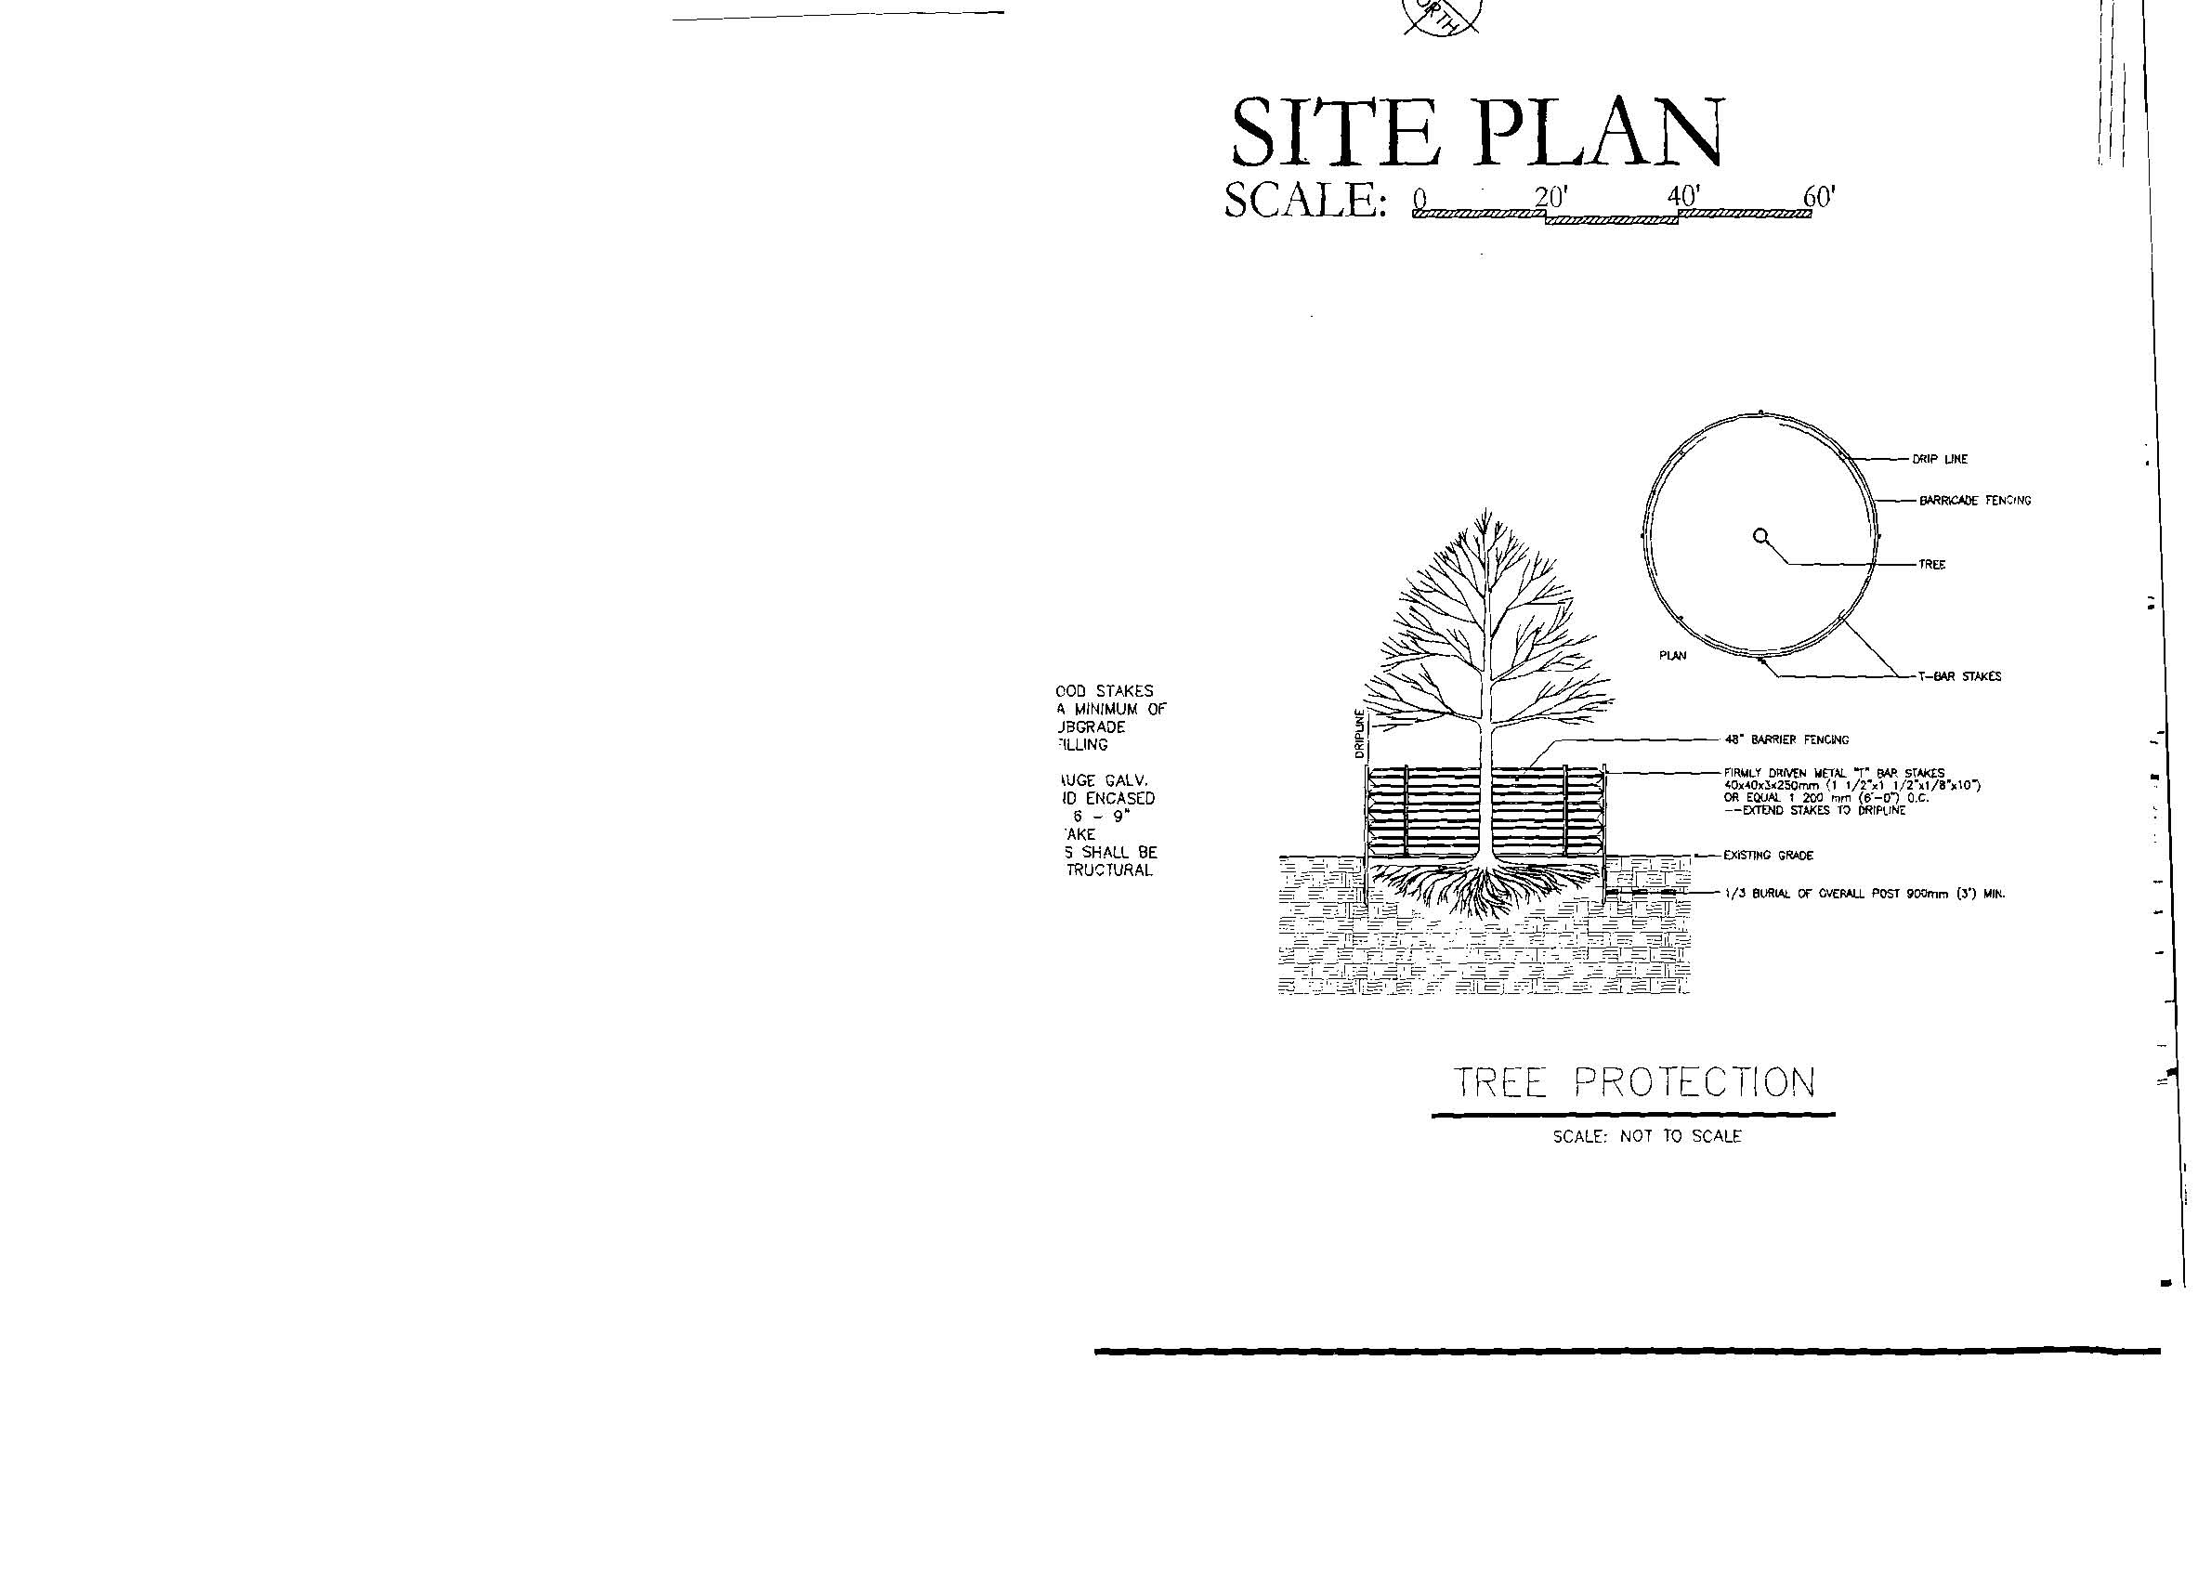


Site Design Specifications

November 2012
BioCorridor Planned Development District

Introduction 3
Table of Contents
Applicability 3
Purpose and Intent 3
Waivers to the Specification 3

Pavement and Surfacing Standards 4
Pavement and Surfacing 4
Curbs 5
Driveway Requirements 6

Bicycle Parking Standards 7

Fire Service Standards 8
Fire Hydrants 8
Fire Department Connection 9
Fire Flow Requirements 9
Fire Apparatus Access Roads (Fire Lanes) 10
Aerial Fire Apparatus Access Roads 11
Fire Lane Markings 11
Fire Apparatus Access Road Gates 12

Solid Waste Standards 13
Dimensions of the Containers 13
Pavement Standards 13
Required Screening 13
Minimum Dimensions for Enclosures 14
Access 16
Dimensions for Maneuvering 17

Sign Standards 18
Sign Visibility 18
Determining Sign Area 18

Landscape & Streetscape Standards 19
Submittal Requirement 19
Tree Preservation 21
Planting List

Gated Entry Standards 26

General Site Plan Notes 27

Applicability
Introduction
The following site design specifications shall be used in the development and redevelopment of all sites in the BioCorridor.

No development approval shall be granted, nor building permit issued, for a development that does not meet the minimum requirements of these Design Specifications, except as provided herein.

Purpose and Intent
The purpose of the BioCorridor Site Design Specifications is to establish and provide the minimum standards to be adhered to in the design and construction of all private improvements. It is the intent to obtain high quality construction throughout, with the completed work complying with the Site Design Specifications.

If required by the BioCorridor Review Committee, the Contractor shall furnish satisfactory evidence (including reports or tests) as to the kind and quality of materials to be used.

Waiver to the Specifications
A waiver to the specifications may be approved by the BioCorridor Review Committee if it is demonstrated that the materials and design are equal or superior to the requirements stated herein.

Pavement and Surfacing
Pavement and Surfacing Standards
Except as otherwise provided, all off-street parking areas, including drive aisles, driveways and parking stalls, shall be constructed with a minimum allowable parking lot pavement of one of the following options:

- Asphalt - a minimum of one and one-half inches (1.5") of asphalt pavement on top of six inches (6") of limestone base.

- Concrete - a minimum of five inches (5") thick; reinforcement within the concrete section shall consist of number four (#4) bars on eighteen inch (18") centers, centered within the pavement thickness.

All off-street parking areas shall be installed graded to drain and shall be maintained so as to dispose of surface water accumulated within the area. Parking spaces shall be arranged and marked so as to provide for the safe and orderly parking of vehicles.

Non-Public, All-Weather drive surfaces, whether temporary or permanent, that are required for emergency access or turnaround for emergency vehicles must be constructed to function under all weather conditions. To accommodate a project during construction, phasing, or permanent installation, drive surfaces that do not meet the requirements for permanent pavement surfaces may be allowed at the discretion of the City’s Administrator for the specific conditions stated below:

- Temporary All-Weather Surface (During Construction): A structure under construction must be accessible by an all-weather drive surface. This surface may consist of the permanent pavement as described above, or may consist of four inches (4") of limestone base with a one-course seal coat as specified in the Texas Department of Transportation Standard Specifications for Construction of Highways, Streets and Bridges, 1993 Edition, Item 316. This temporary all-weather surface must be reworked or replaced to meet the permanent pavement standard as described above prior to issuance of a Certificate of Occupancy.

- Semi-Permanent All-Weather Surface (During Phasing): In cases during phasing of a large project, emergency access and turnarounds often must be added as a temporary measure until additional phases are constructed. These emergency access areas may consist of permanent pavement surface as described above, or may consist of six inches (6") of limestone base with one-course seal coat as specified in the Texas Department of Transportation Standard Specifications for Construction of Highways, Streets and Bridges, 1993 Edition, Item 316. If the semi-permanent surface is used, the six-inch (6") curb is not required, and these areas must be gated or protected from public usage and signed for emergency access only. When the additional phase is constructed these areas must be removed or reworked to meet the permanent pavement standards as described above.

- Permanent All-Weather Surface (Permanent): In some development scenarios, an emergency access or turnaround must be constructed to meet emergency access purposes and is not required for public traffic, service vehicles or sanitation vehicles. In these cases, the area required for emergency access only may consist of permanent pavement surface as specified above, or may consist of

six inches (6") of limestone base with a two-course seal coat as specified in the Texas Department of Transportation Standard Specifications for Construction of Highways, Streets and Bridges, 1993 Edition, Item 316. If the seal coat surface is used, a six-inch (6") curb is not required, and these areas must be gated or protected from public usage and signed for emergency access only.
Pavement and Surfacing Standards
Curbs
A six inch (6") raised monolithic concrete curb shall be required around the entire perimeter of all paved areas, including all parking islands. Design of the combined curb and gutter section must meet minimum standards as shown in the diagram below:
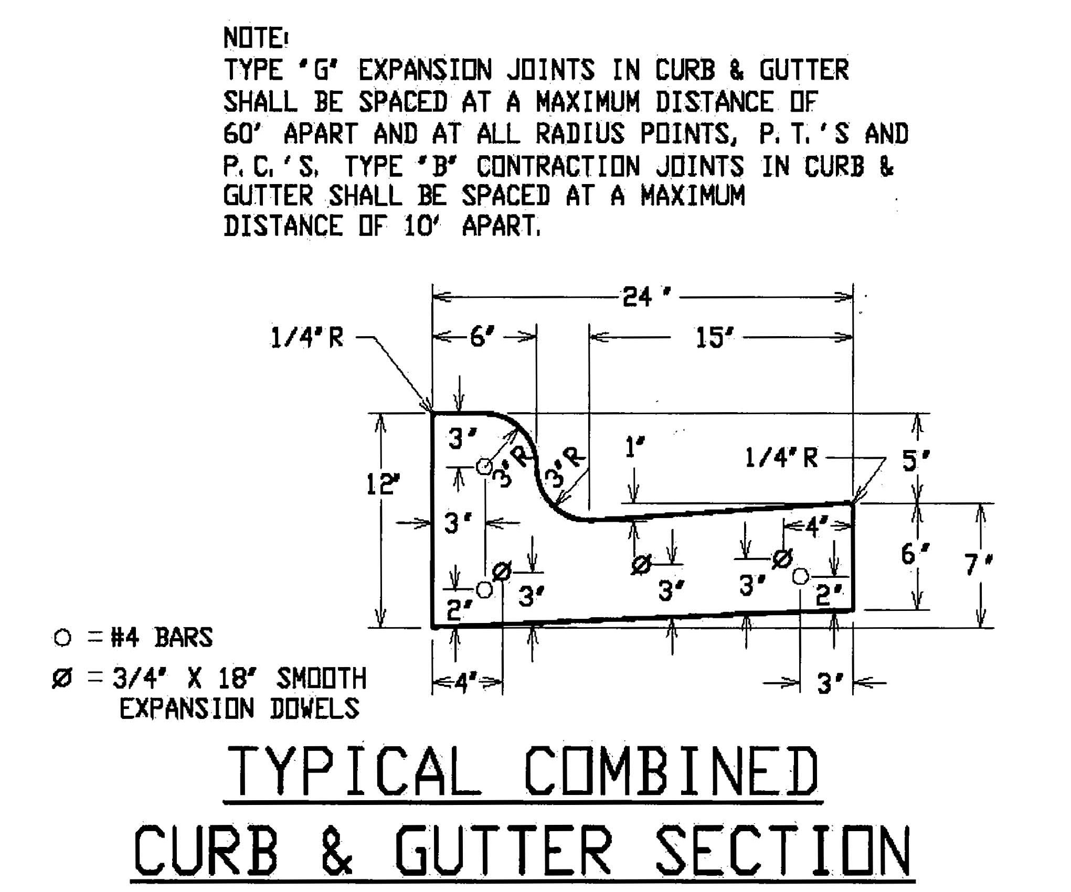

Temporary Curbing
A temporary six inch (6") raised concrete curb may be permitted in lieu of the minimum standard stated above, at the discretion of the Administrator, when a project is phased in such a way that a permanent, monolithic curb may preclude development of future phases or limit access to a recorded private or public access easement adjoining properties. Wheel stops shall not be permitted as temporary curbing. Temporary curbing must have the appearance of permanent curbing and shall be temporarily attached to the pavement surfacing below and meet the minimum standards for dowelled in curbs as shown in the diagrams below:
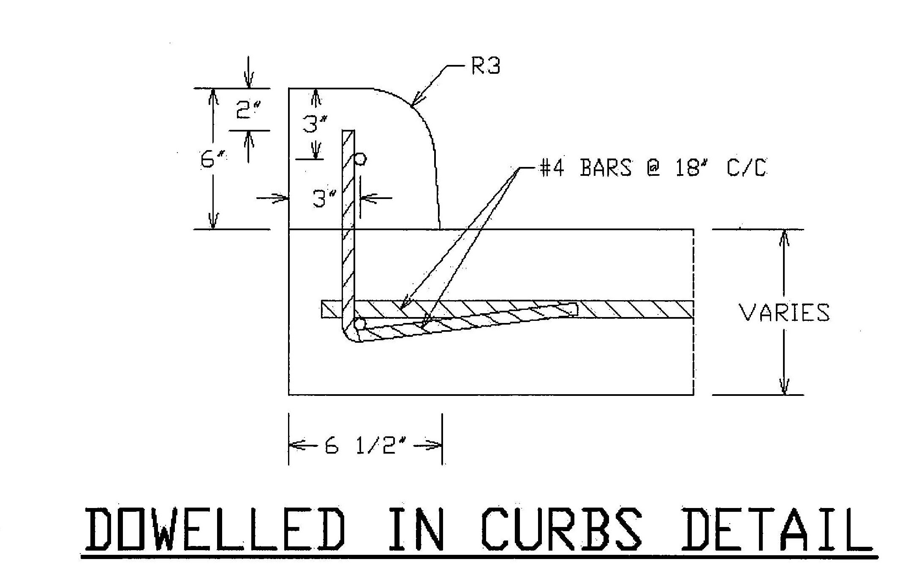
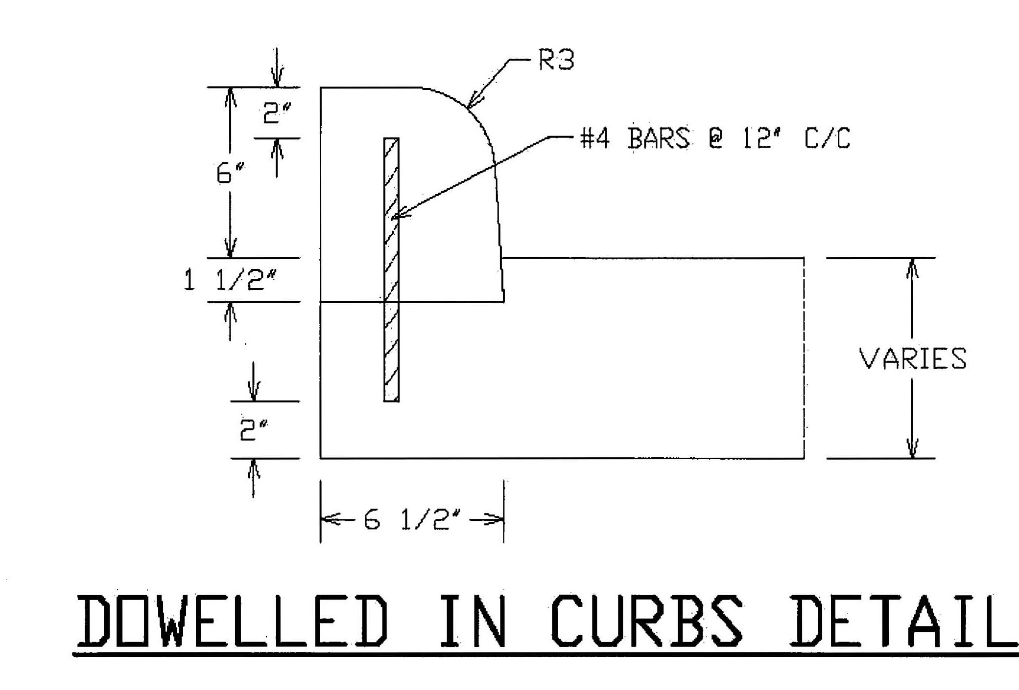

Driveway Requirements
Commercial Driveways shall be constructed to the standard shown in the detail below:

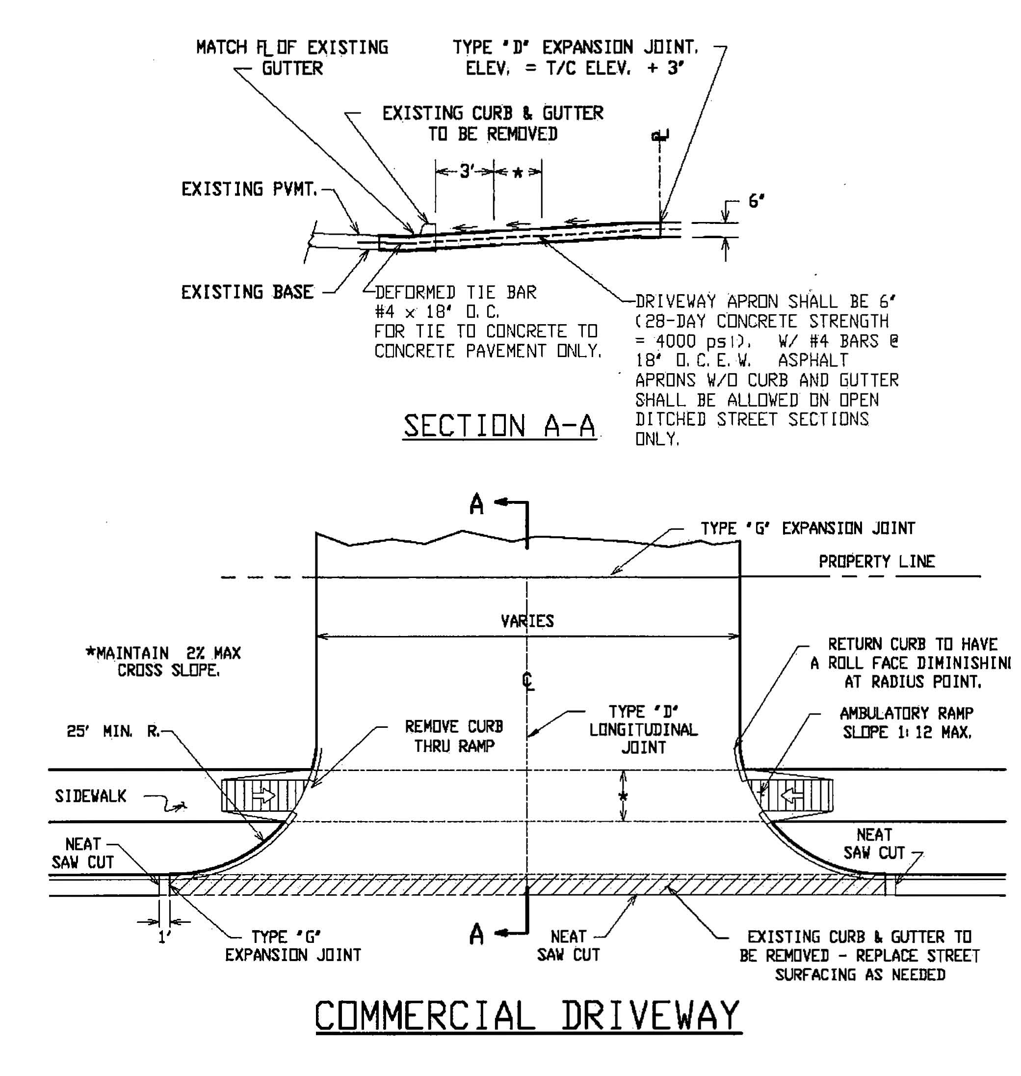

Pavement and Surfacing Standards
Detail of a typical Concrete Driveway Apron:
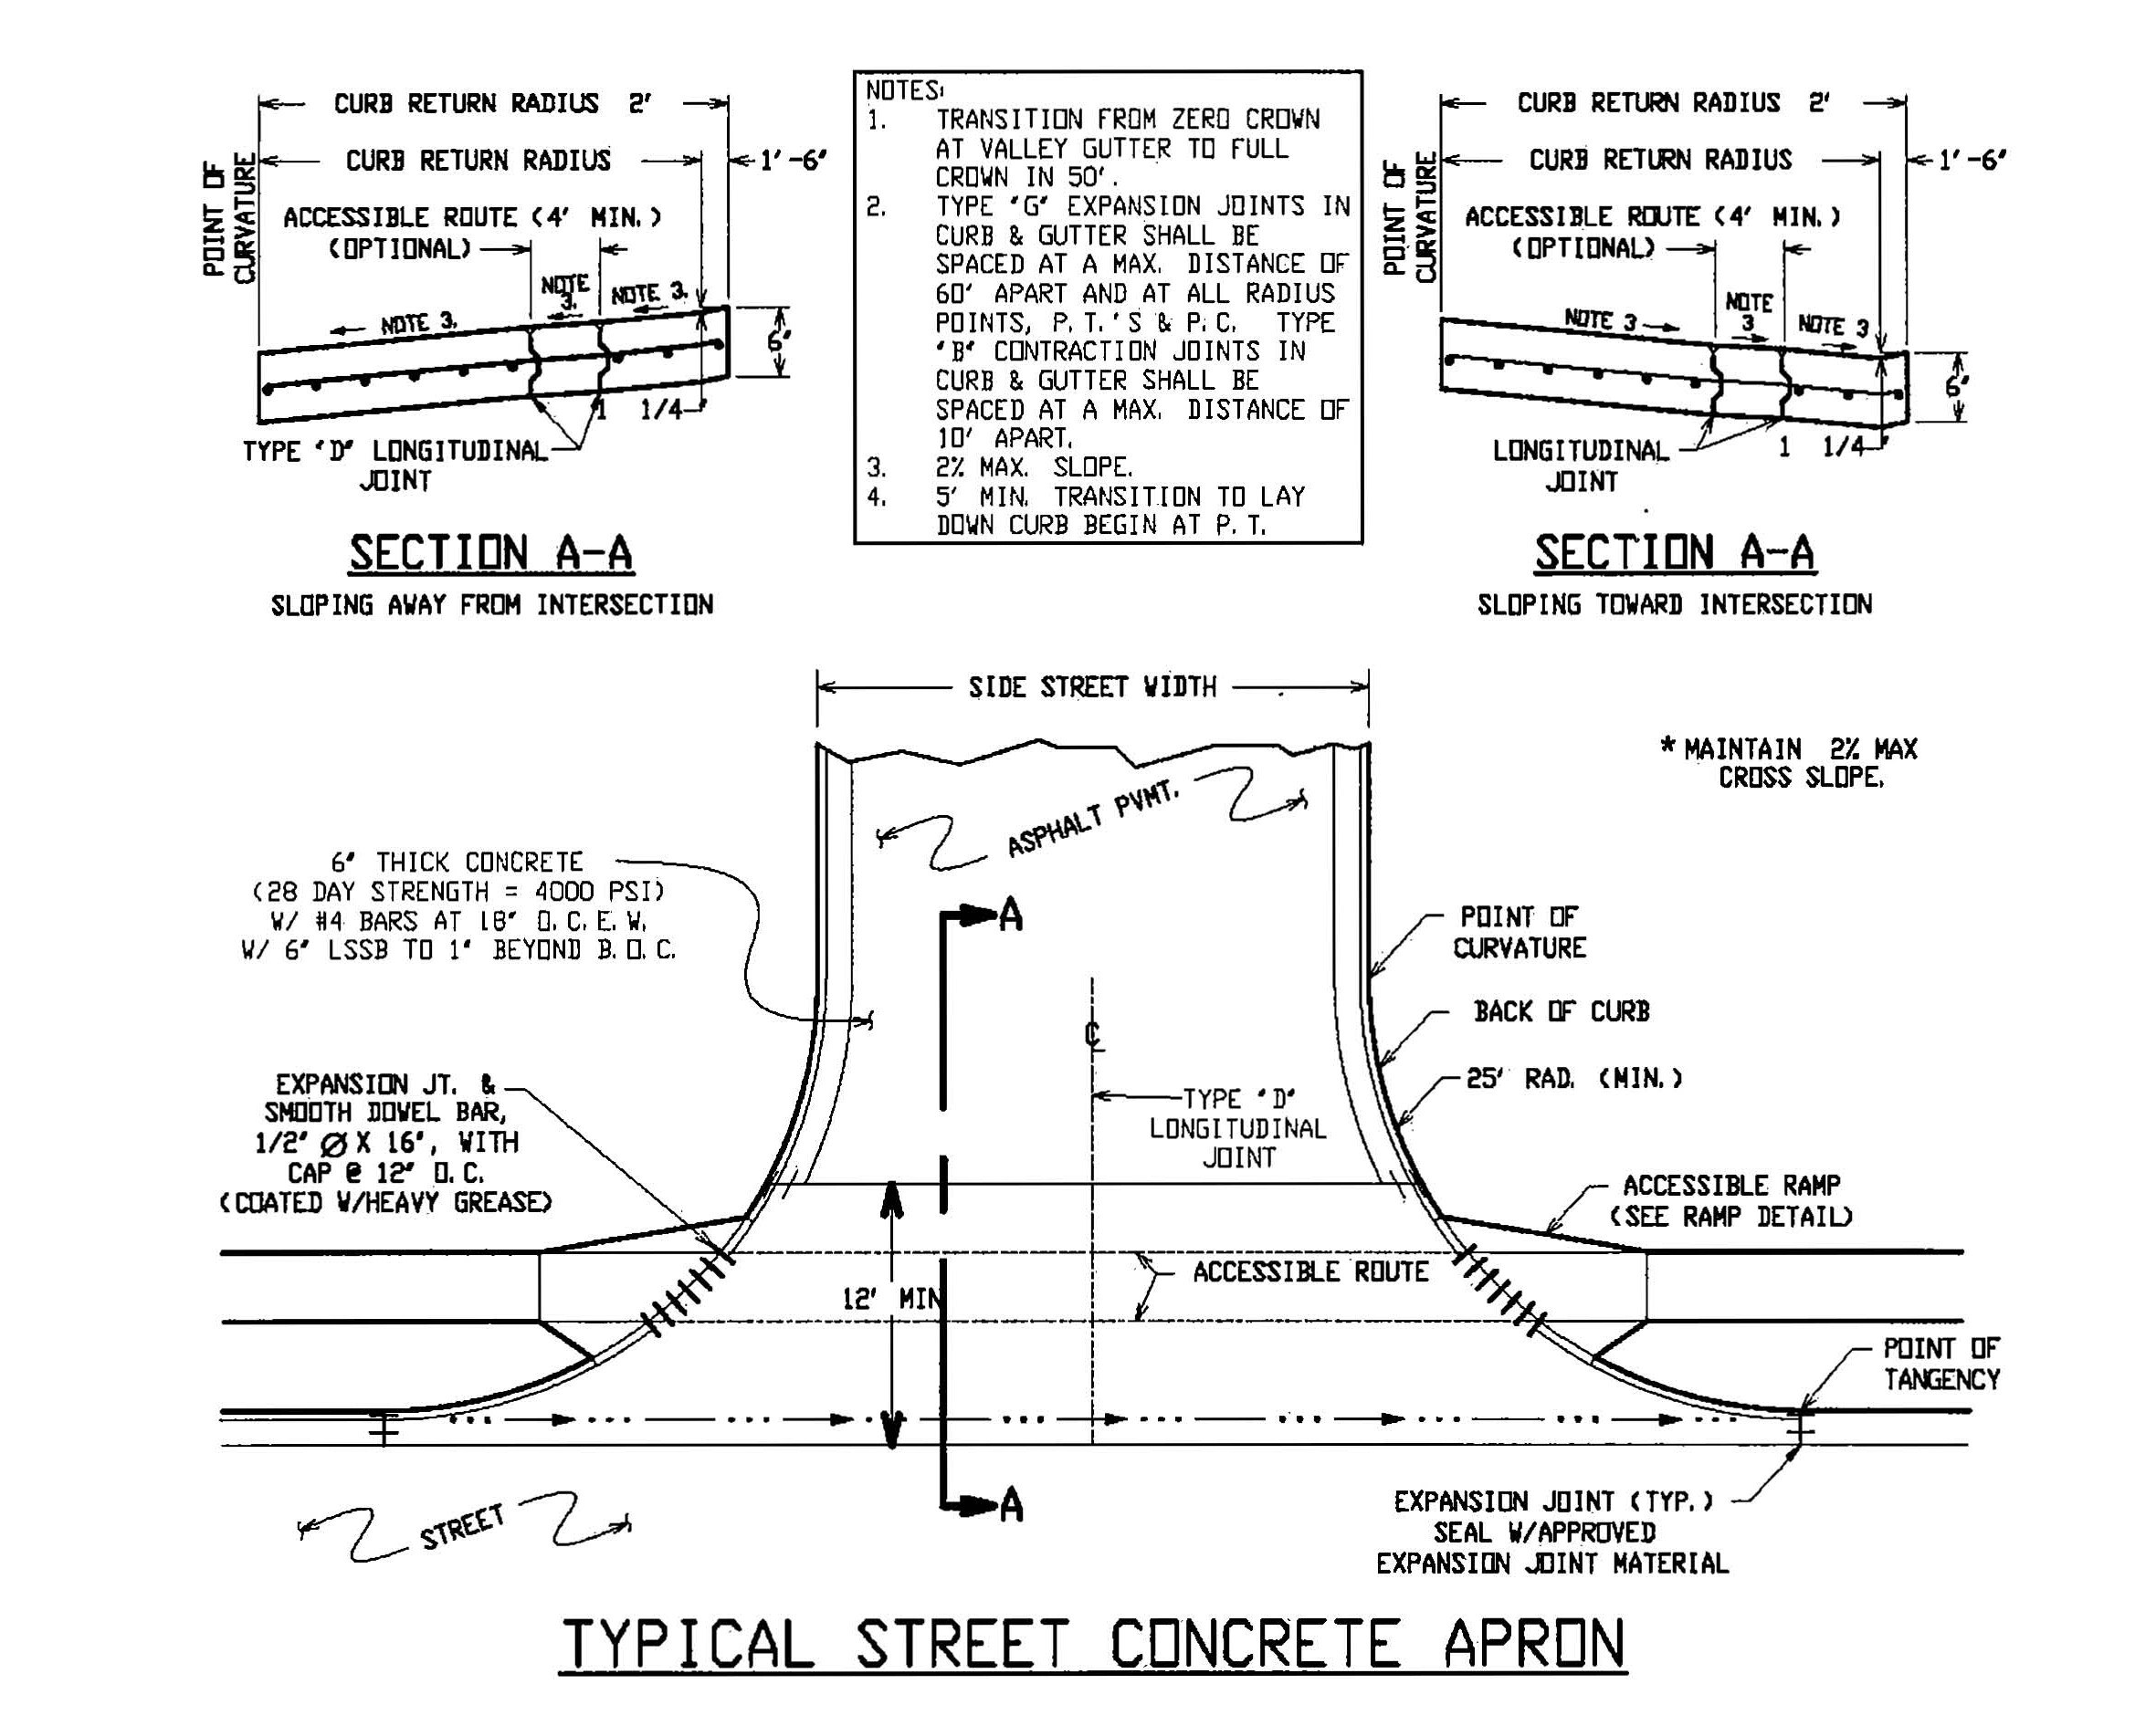

Bicycle Parking Standards
Bicycle Parking
Each building shall provide a facility capable of storing a minimum of four (4) bicycles. The area provided for such a facility shall be approximately 55 square feet in area, approximately nine feet by six feet (9’ X 6’), or as approved by the BioCorridor Review Committee.

Approved bicycle facilities shall utilize the design and dimensions shown below.

Bicycle Parking Space Layout:
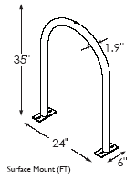
30” (min)
15”
15”
6”
6”
24”
24”
36”
36”
6” @ each end

DRAWING NOT TO SCALE
72”
All fire service features, including, but not limited to, apparatus access roadways, fire flows, and fire hydrant locations and distribution must meet the International Fire Code, as adopted and amended.
Fire Service Standards

Fire Hydrants
Fire hydrants must be placed along an approved fire lane. Hydrants shall be located so that no part of any structure, above ground tanks or fueling stations shall be more than three hundred feet (300') from a fire hydrant as measured along an approved fire lane as the fire hose is laid off the fire truck. In no case shall this distance be measured across grass, wooded or landscaped areas, over curbs, through fences, through ditches or across paved areas which are not designed and maintained as fire lanes.

No part of any commercial structure shall be located outside the limits of a one hundred fifty foot (150’) arc from a point where fire apparatus can operate.

Fire hydrants must be located on the same side of a public street as the structures it is intended to serve, and must be accessible at all times. Parking stalls are not permitted to be located between the fire hydrant and the fire apparatus access road. A three foot (3') clear space is required on all sides of the fire hydrant.

The number and spacing of fire hydrants shall not be less than shown in the following chart.

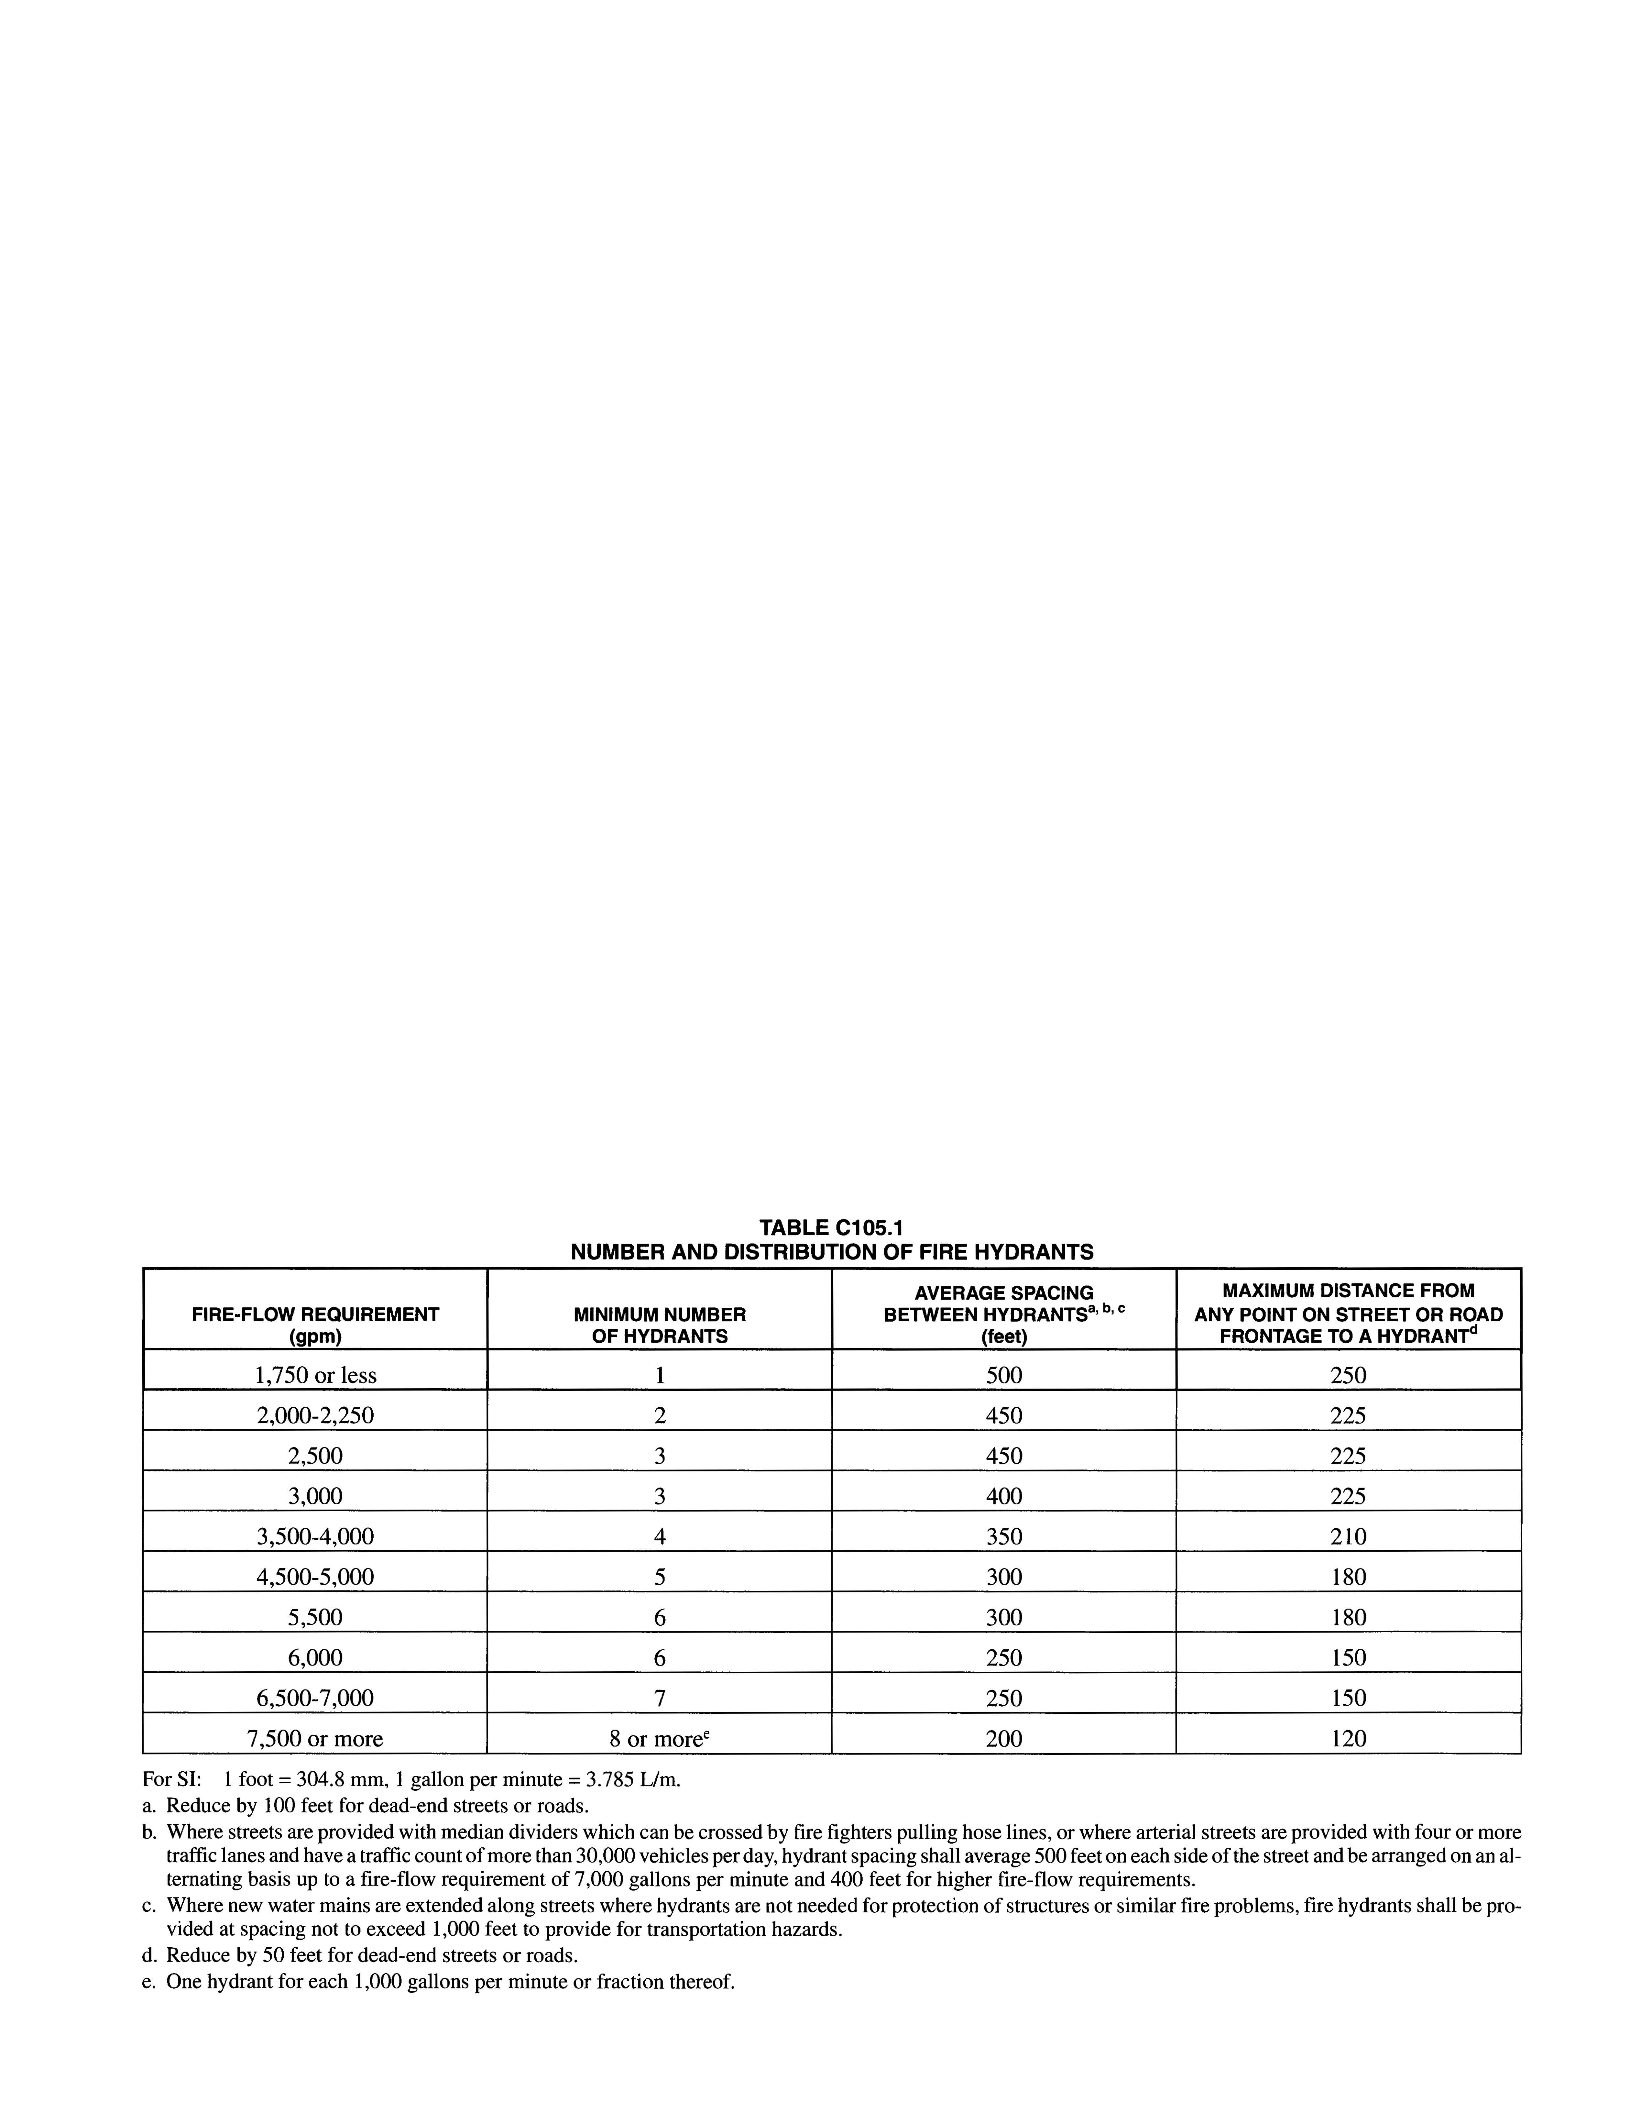

Fire Department Connection (FDC)
All buildings, or portions of buildings, 12,000 square feet in area or larger, per the International Building Code, as amended, and/or all structures exceeding two stories in height, regardless of area, are required to utilize an automatic sprinkler system throughout the building. Portions of buildings that are separated by fire walls without openings, constructed in accordance with the International Building Code, may not require an automatic sprinkler system if smaller than 12,000 square feet in area. Some assembly uses intended for food and/or drink consumption including, but not limited to banquet halls, night clubs, restaurants, taverns, and bars that exceed 5,000 square feet in area shall require an automatic sprinkler system. A Fire Department Connection (FDC) is required for all buildings utilizing an automatic sprinkler system. The FDC must be located within 150 feet of a fire hydrant.
Fire Service Standards
Fire Flow Requirements
In general, the calculation area for fire flow requirements is based on the total gross area of the structure, including any area under the horizontal projections of the roof of the structure. Portions of the building that are separated by fire walls without openings and constructed in accordance with the International Building Code, may be considered as separate areas for the purposes of fire flow calculations. For type IA and type IB construction, the calculation shall be based on the area of the three largest successive floors.
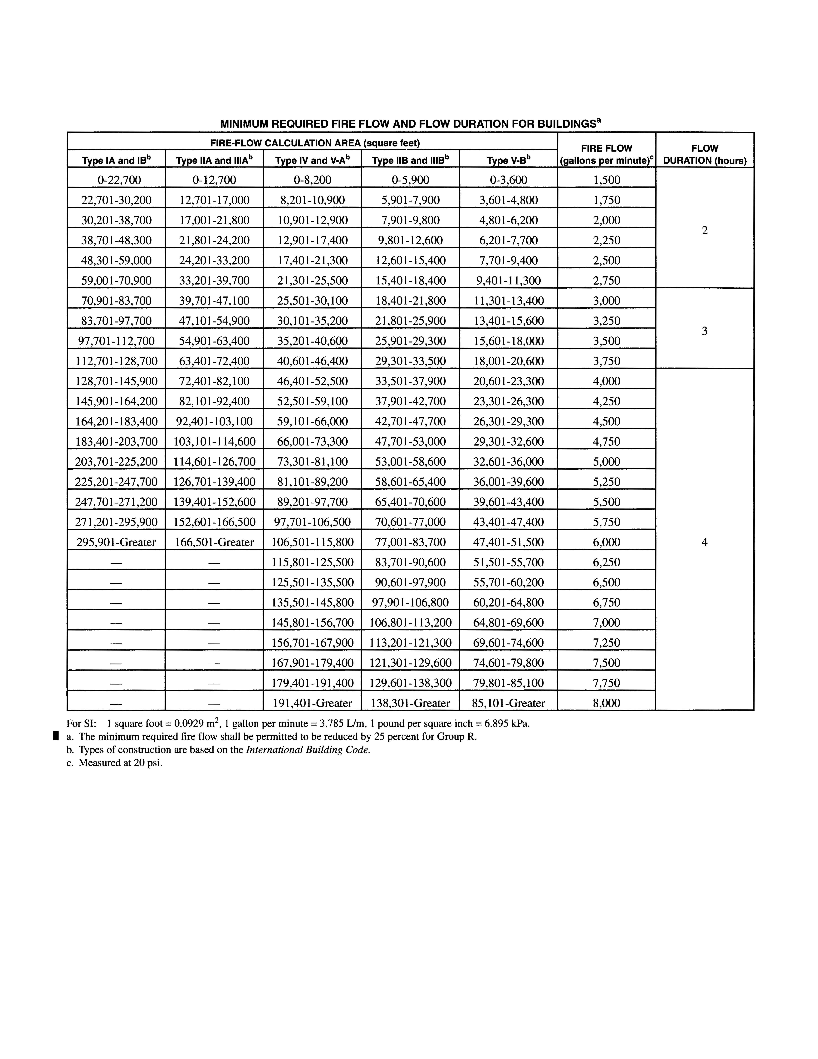
Fire Apparatus Access Roads (Fire Lanes)
Fire Service Standards
All fire lanes shall be constructed using the following minimum standards or equivalent, as approved by the BioCorridor Review Committee:

- Asphalt - a minimum of one and one-half inches (1.5") of asphalt pavement on top of six inches (6") of limestone base.

- Concrete - a minimum of six inches (6") thick, the reinforcement within the concrete section shall consist of number four (#4) bars on eighteen inch (18") centers, centered within the pavement thickness.

Fire lanes shall be a minimum of 20 feet (20') in width and have a minimum unobstructed height of fourteen feet (14'). Fire lanes in excess of 100 feet shall provide a turn around as provided for in the following table and graphics.
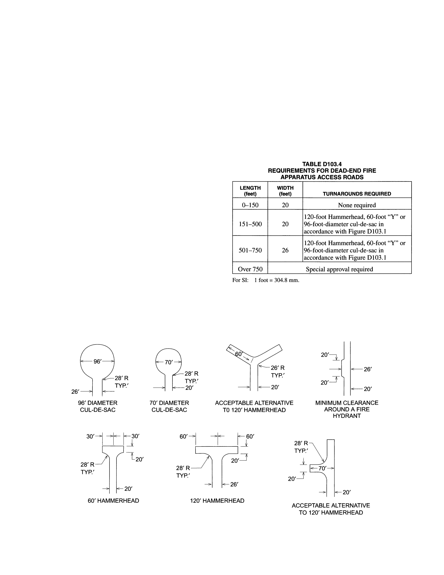

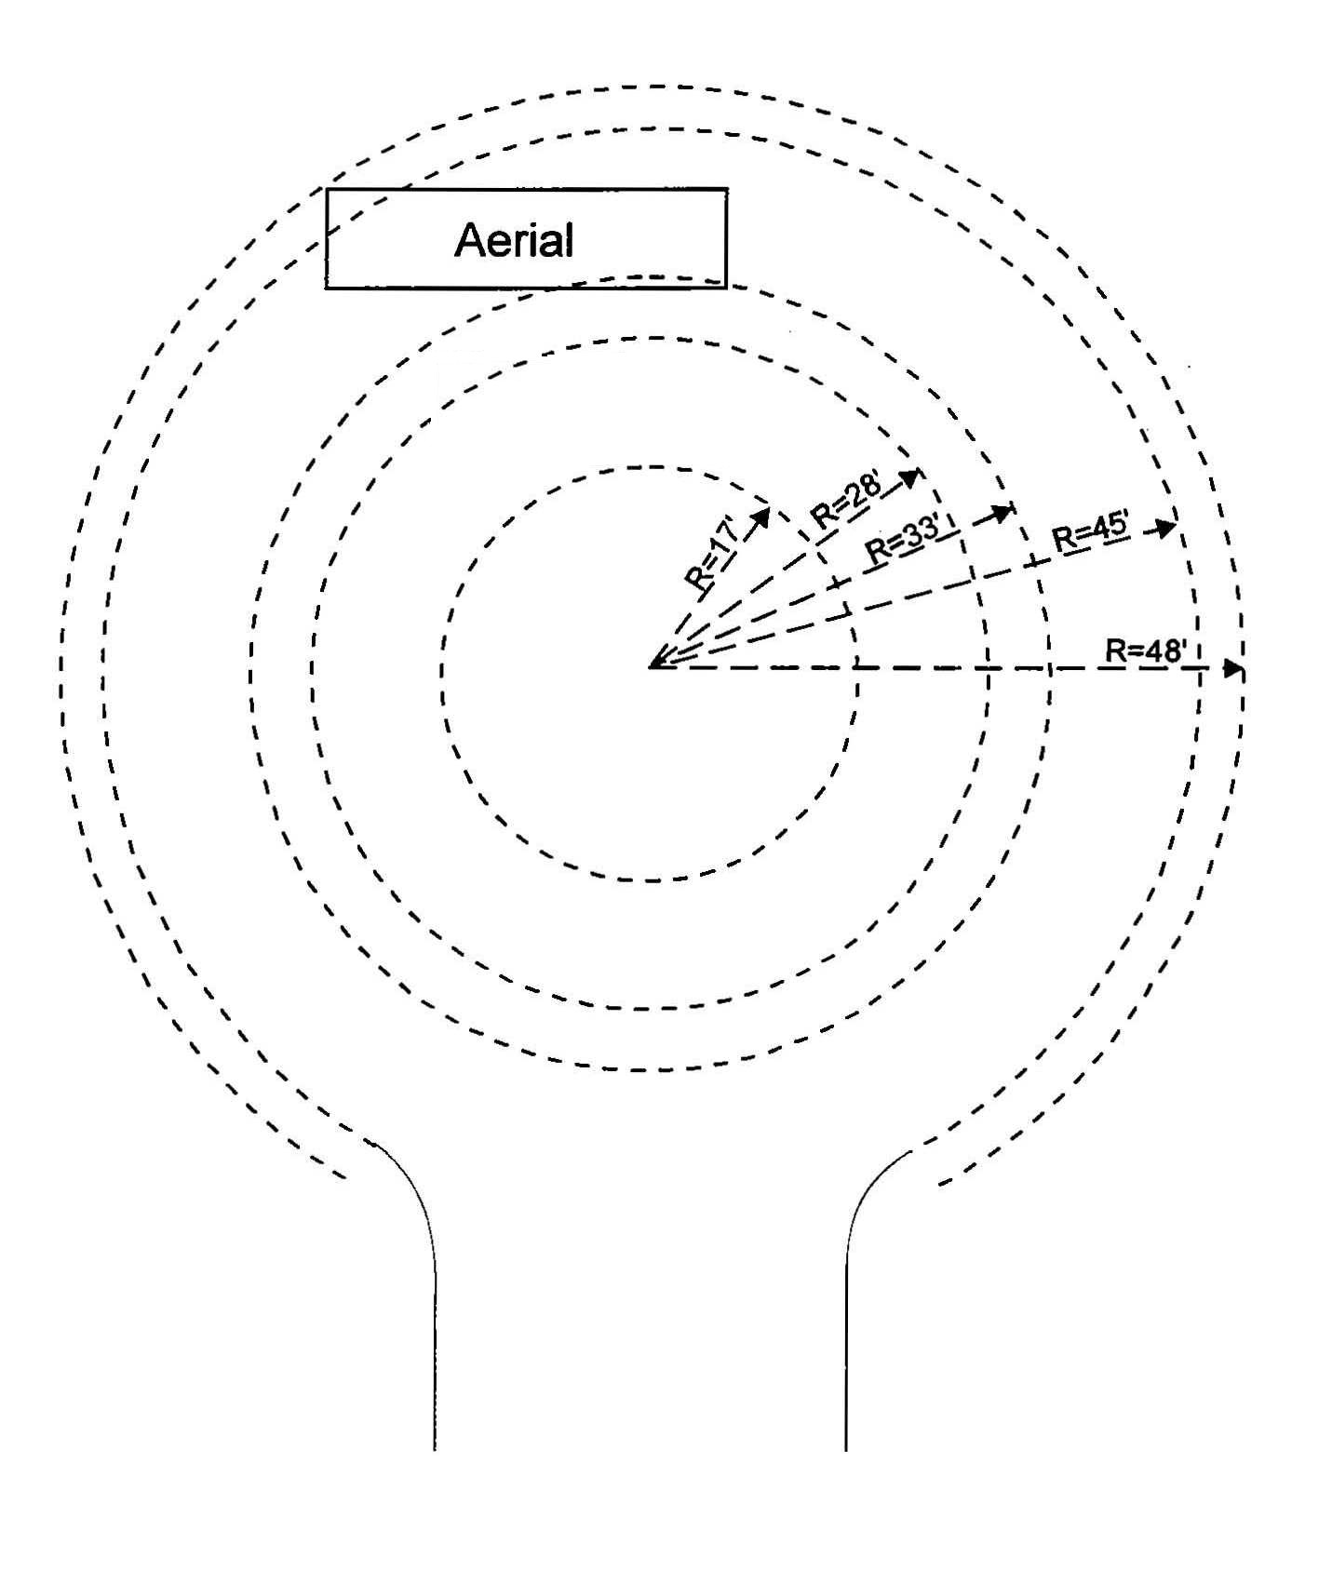
All fire lanes shall meet the following turning radii for an aerial truck:
Fire Service Standards

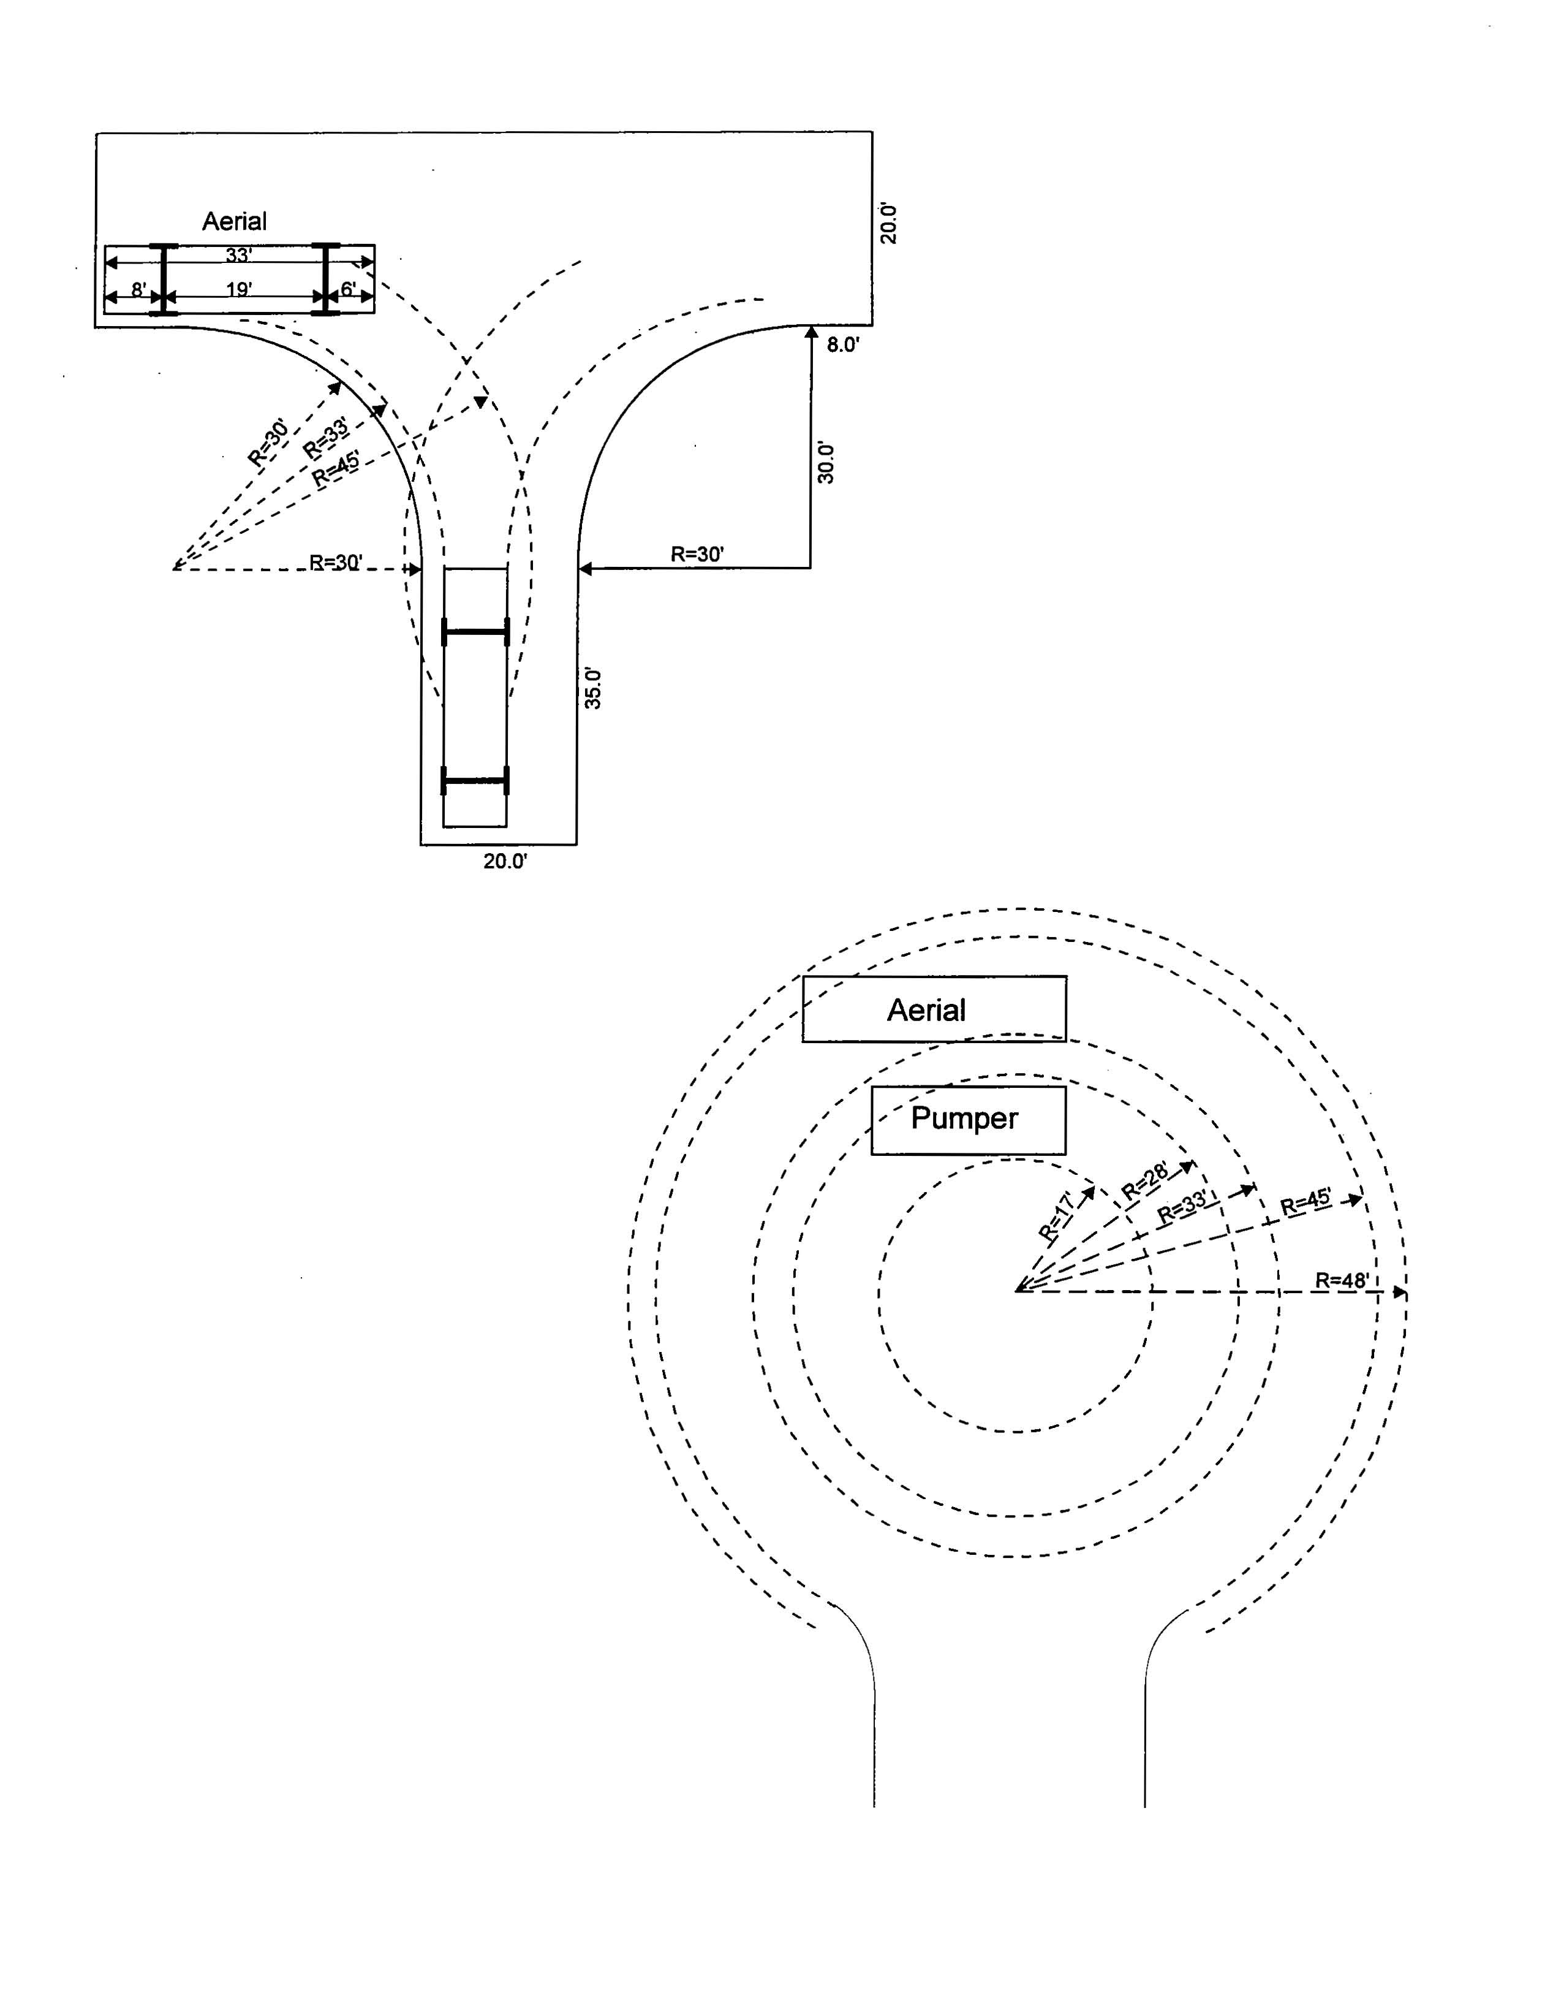

Aerial Fire Apparatus Access Roads
For all structures or portions of structures, including parapets and other obstructions to the roof of the building, exceeding 30 feet in height, an aerial fire apparatus access road shall be required parallel to one entire side of the building to provide access to the roof of the structure. Aerial fire apparatus access roads shall be a minimum of 26 feet in width and be located within a minimum of 15 feet and a maximum of 30 feet from the building. Overhead utilities shall not be located within an aerial fire apparatus access road.

Fire Lane Markings
All curbs and curb ends shall be painted red with four inch (4") white lettering stating "FIRE LANE - NO PARKING - TOW AWAY ZONE". Wording may not be spaced more than fifteen feet (15') apart.

In areas where fire lanes are required, but no continuous curb is available, one of the following methods shall be used in conjunction with the curb markings to indicate that the fire lane is continuous:

Option 1: A sign twelve inches (12") wide and eighteen inches (18") in height shall be mounted in a conspicuous location at each entrance to the property. Such signs shall be twelve inches (12") wide and eighteen inches (18") high, with a companion sign twelve inches (12") wide and six inches (6") high stating "Tow-Away Zone". Such signs shall be painted on a white background with symbols, letters and border in red.

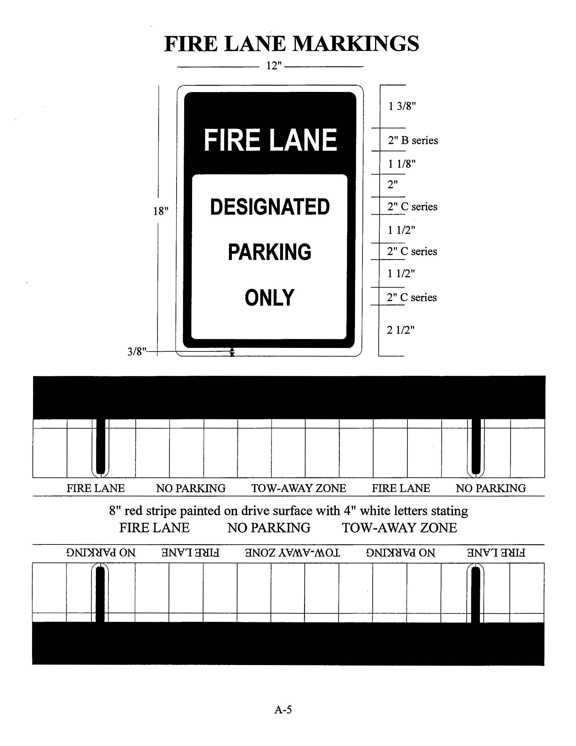
Fire Service Standards
Option 2: From the point the fire lane begins to the point the fire lane ends, including behind all parking spaces which adjoin a fire lane, shall be marked with one continuous eight inch (8") red stripe painted on the drive surface behind the parking spaces. All curbing adjoining a fire lane must be painted red. Red stripes and curbs will contain the wording "FIRE LANE - NO PARKING - TOW AWAY ZONE", painted in four inch (4") white letters.

In those cases where curb markings are not possible or where signs would, in the City’s Fire Marshal's opinion, work more effectively, the City’s Fire Marshal may require signs in lieu of curb markings.

Fire Apparatus Access Road Gates
Fire Service Standards
Gates obstructing a fire lane must have a minimum width of 20 feet and utilize either swinging or sliding gates. All security gates must have a Knox key box and manual operation must be able to be by one person. Gates may not be locked with a pad lock or chain.

Access to Multi-Family Developments
Mixed-use developments with 100 multi-family dwelling units or greater require a second point of ingress / egress from the development to the public right-of-way. In the case that the units have an approved fire suppression system, the number of dwelling units requiring a second point of ingress / egress is 200.

Requirements pertaining to the type and number of solid waste containers or frequency of collection are based on the type of commercial activity at the location, and the size of the development itself.
Solid Waste Standards

Dimensions of the Containers
- A 300-gallon side-loading automated container is 52 inches in diameter and 48 inches tall.
- A 4-yard front-end-loading dumpster is 4 feet wide by 6 feet long and 5 feet tall
- An 8-yard front-end-loading dumpster is 6 feet wide by 6 feet long and 6 feet 6 inches tall.
- A 30-yard roll-off compactor is 8 feet wide by 24 feet long.

Pavement Standards
All sanitation service routes on site shall be constructed with the following minimum standards:

- Asphalt - a minimum of one and one-half inches (1.5") of asphalt pavement on top of six inches (6") of limestone base.

- Concrete - a minimum of six inches (6") thick, the reinforcement within the concrete section shall consist of number four (#4) bars on eighteen inch (18") centers, centered within the pavement thickness.

All required container and dumpster pads shall be constructed of concrete six inches (6") thick. The reinforcement within the concrete section shall consist of number four (#4) bars on 18-inch centers, centered within the pavement thickness.

Required Screening
All containers are required to be screened from the right-of-way and all adjacent properties by a six foot high opaque screen. A gate is required when opening is in view of the public right-of-way, except for 300-gallon side-loading automated containers. Gates shall have a minimal width of 12 feet when open, shall swing 180 degrees from the closed position, and shall utilize a positive-locking mechanism while in the open position.

The 300-gallon side-loading automated container enclosure shall be open on the side facing the collection point. The open side cannot be facing the public right-of-way.

Enclosures shall not be placed in drainage flow areas.

It is the City’s preference that screening structures be located outside of any public easement. If maintenance of City utilities requires the removal of a screening structure, it must be replaced at the property owner's expense.

Minimum Dimensions for Enclosures:
Bollards and other such obstructions shall not be set within the minimum dimensions for enclosures.

Interior clearance (inside the screen) dimensions for a:
- Single 300-gallon container (side-loading) enclosure shall be ten feet deep x ten feet wide (10' x 10').

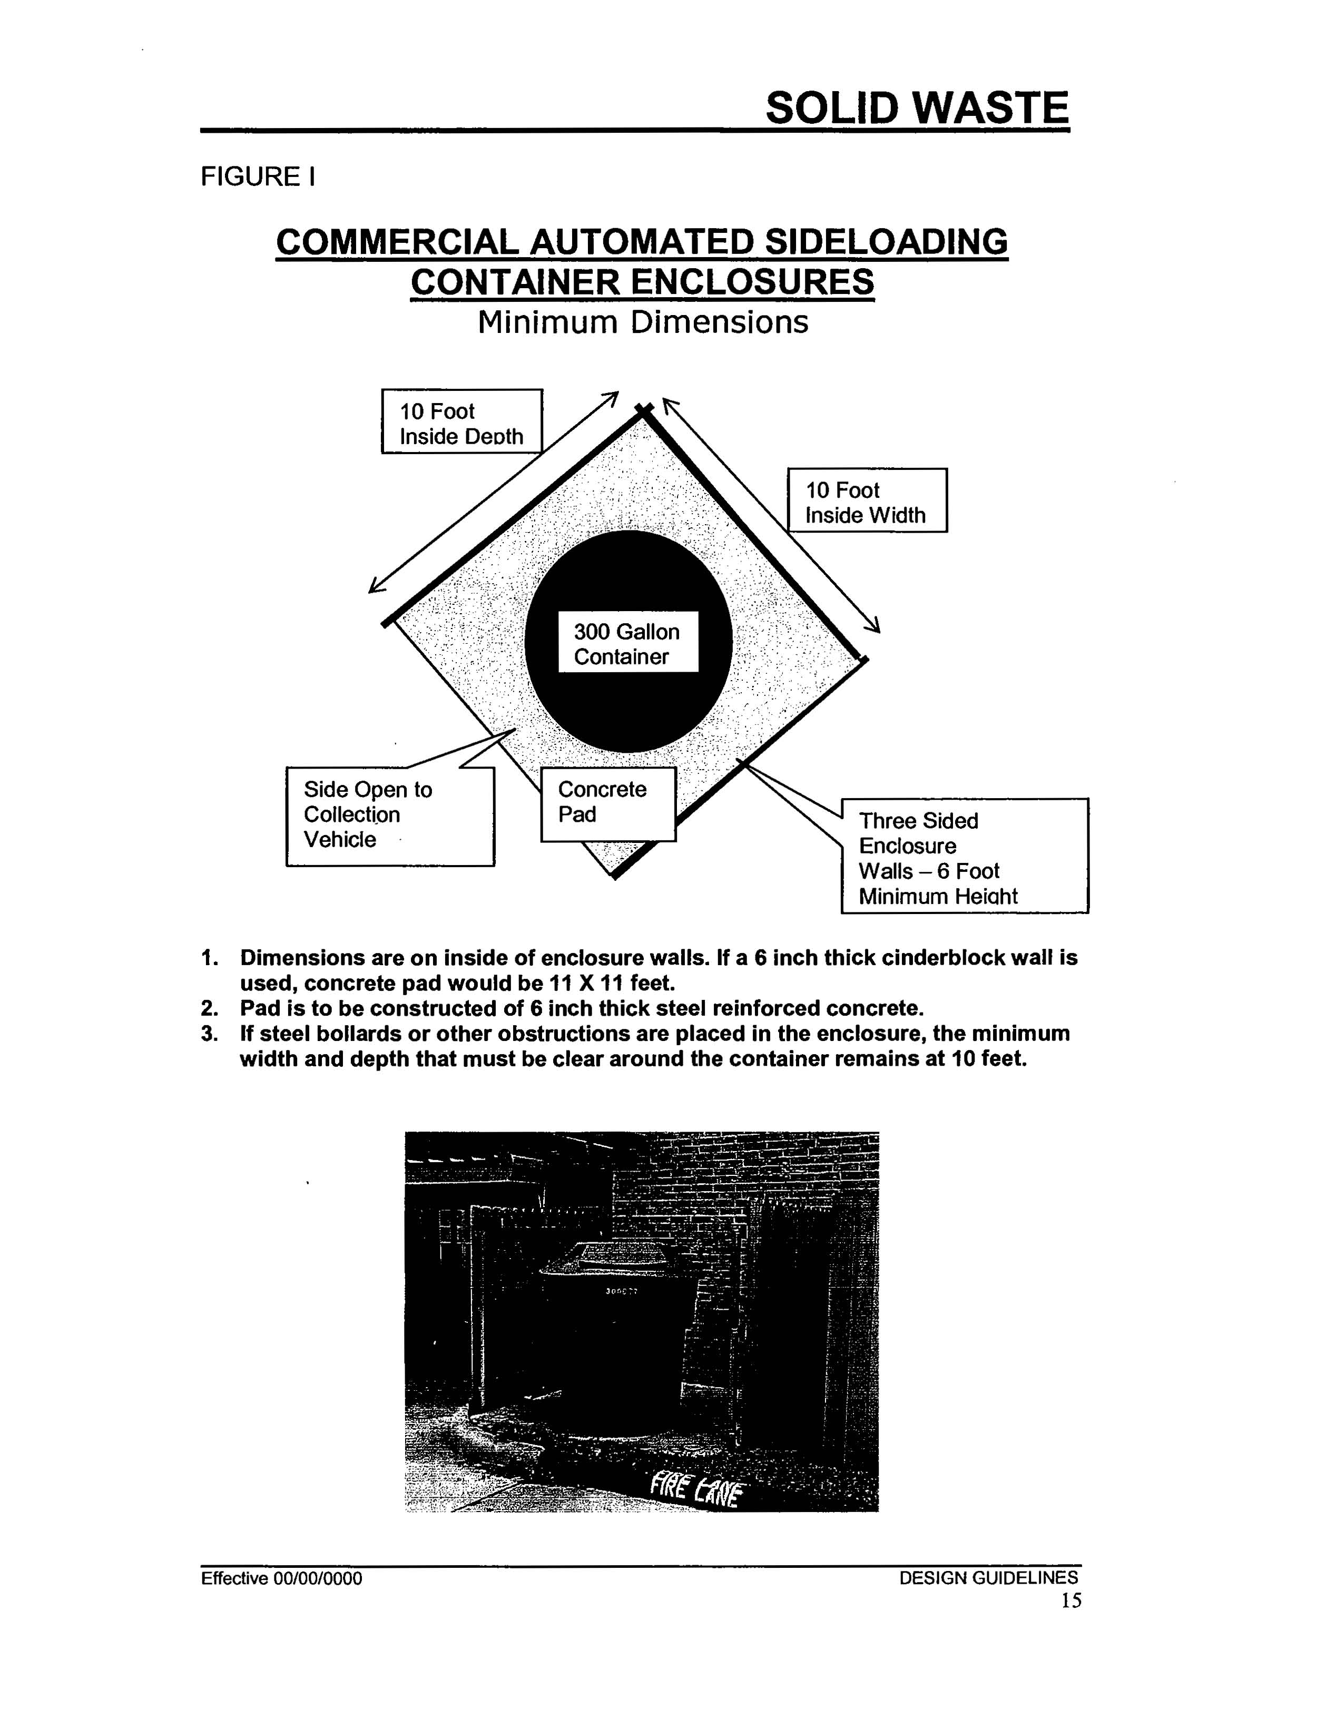
Solid Waste Site Standards

- Single (one four-yard or one eight-yard) dumpster enclosure shall be 12 feet deep x 12 feet wide. The minimum width of the gate or doors shall be no less than 12 feet.

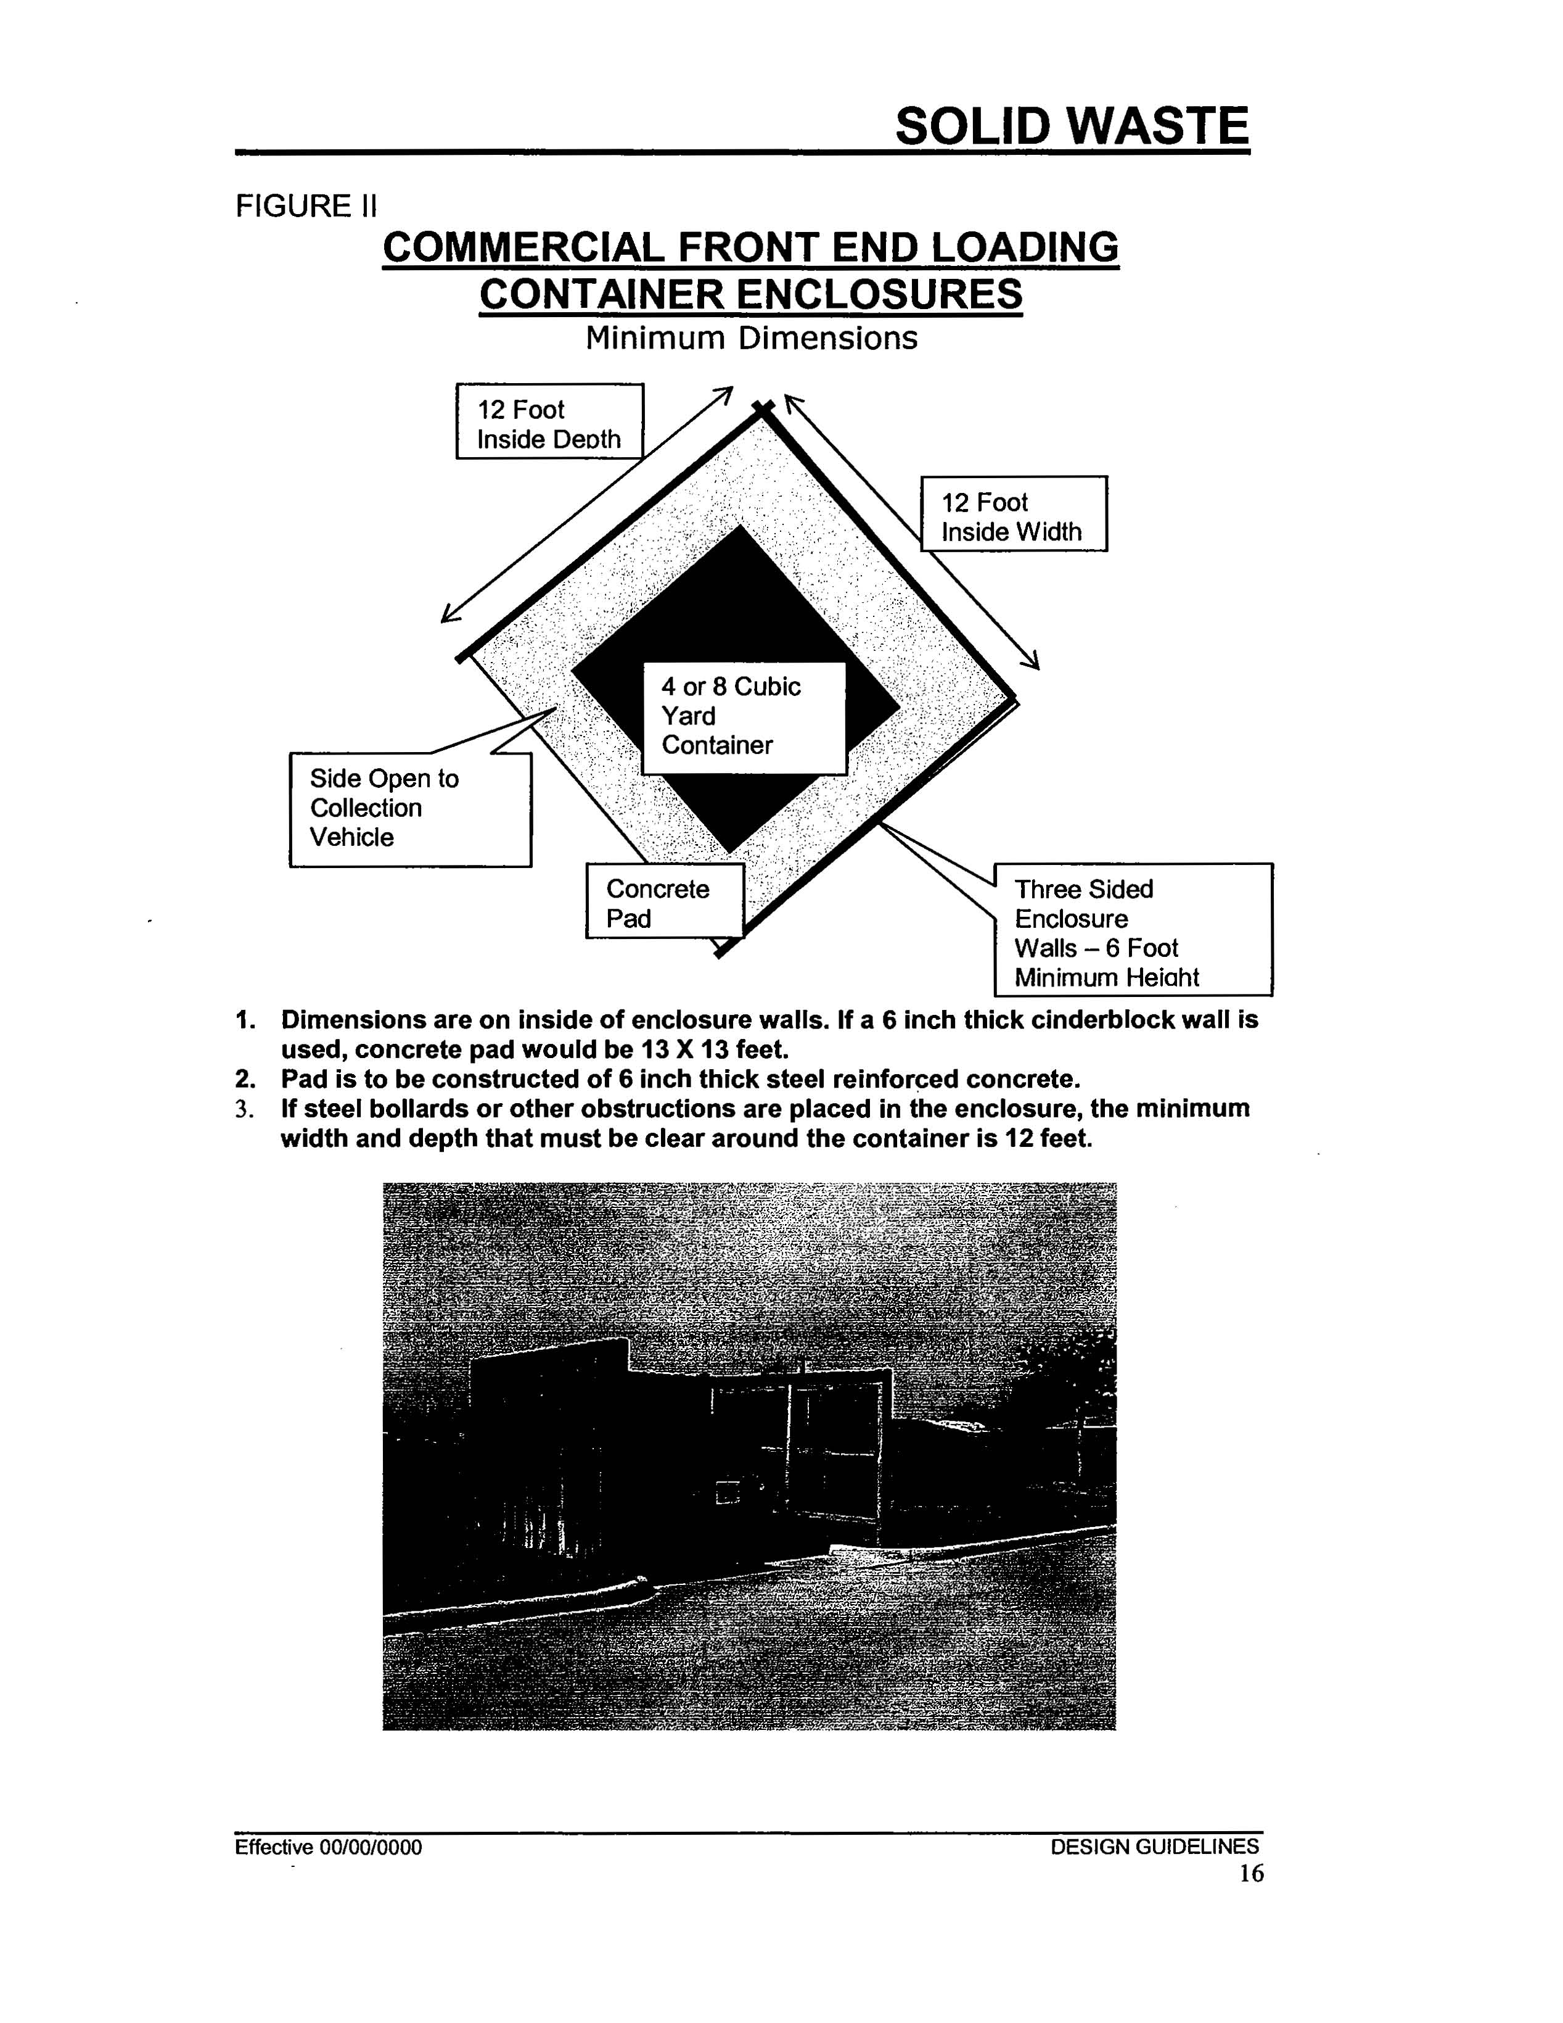

- Double (two four-yard or two eight-yard) dumpster enclosure shall be 12 feet deep x 24 feet wide. The minimum width of the gate or doors shall be no less than 24 feet.

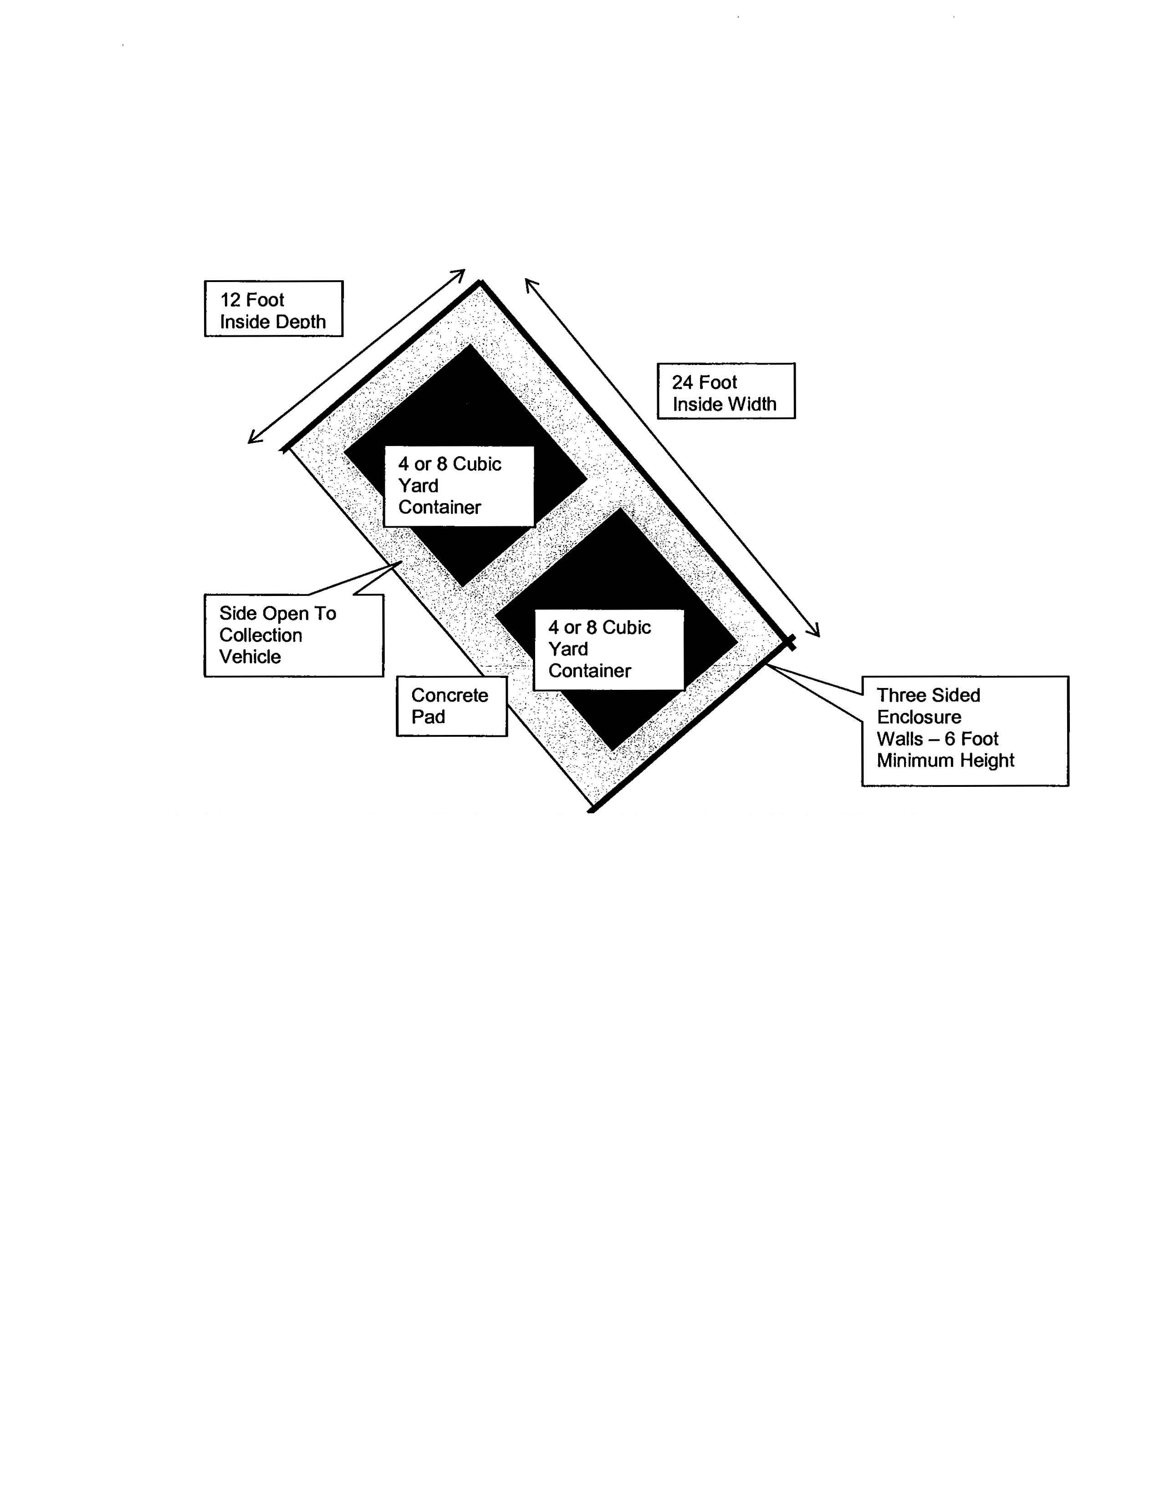
Solid Waste Site Standards

- Triple (three eight-yard) dumpster enclosure shall be 12 feet deep x 36 feet wide. The minimal width of the gate or doors shall be no less than 36 feet.

- A 30-yard roll-off compactor enclosure shall be 29 feet deep x 16 feet wide. The minimal width of the gate or doors shall be no less than 12 feet.

Access
Solid Waste Site Standards
Access areas shall be a minimum of 20 feet in width and have a minimum unobstructed height of 14 feet. Outside turning radii in these areas shall be a minimum of 45 feet.

At no time shall the collection vehicle be required to back more than 100 feet while on the property, or be required to back out into or from a public right-of-way. In such cases, a tee or circle turnaround that meets the minimum fire lane standards, as shown below, will be required.
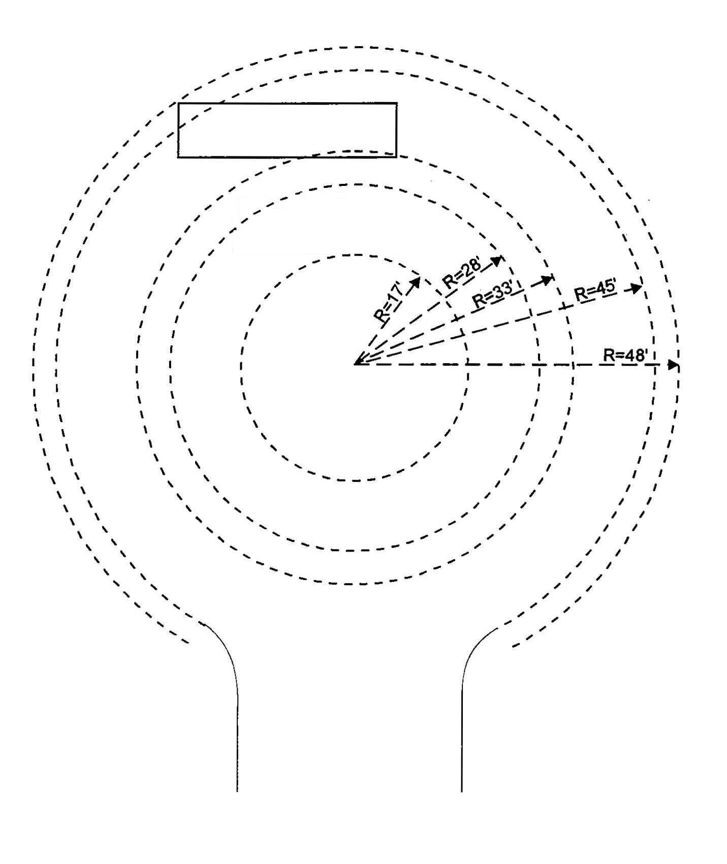
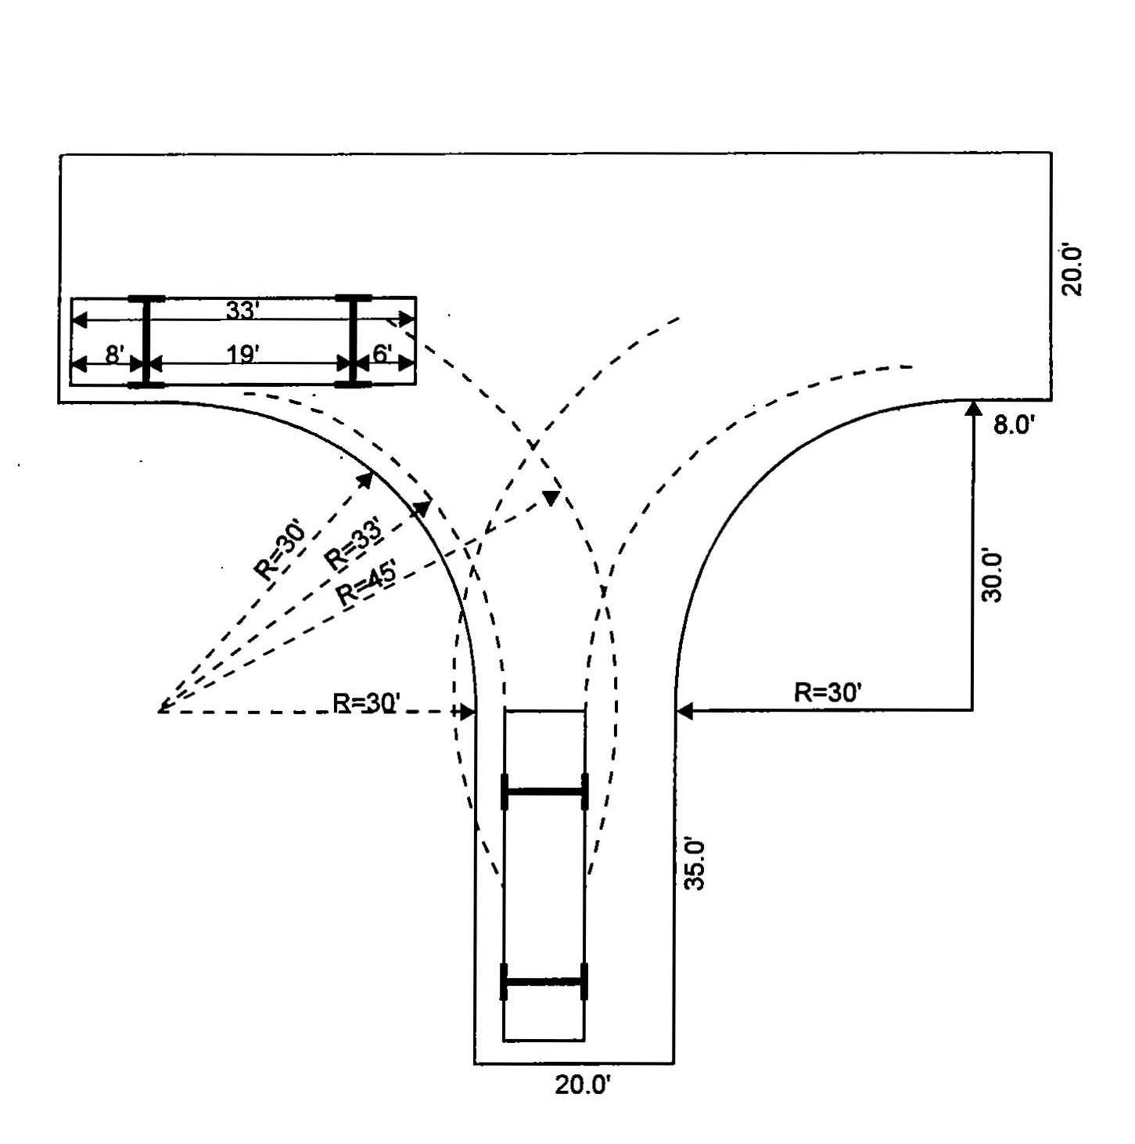

In all cases, approach design should facilitate a looping or circle ingress / egress path that avoids the necessity of the collection vehicle having to conduct backing maneuvers as much as possible.

Dimensions for Maneuvering
Solid Waste Site Standards
Depending on the angle of the enclosure from the access path, a clear maneuvering area of up to 65 feet in front of the container, as shown below, will be required. No parking will be allowed in the maneuvering area.

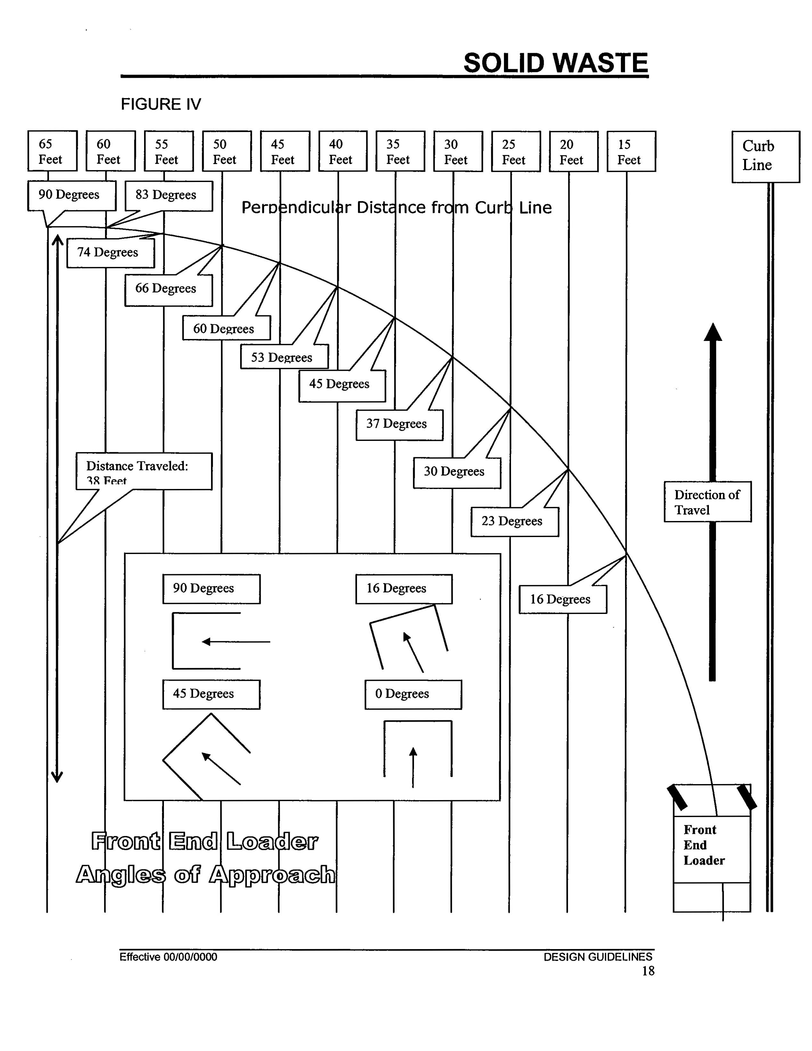

Sign Visibility
Sign Standards
The BioCorridor Review Committee has the authority to determine what is "not easily identified" or visible, as measured from any applicable property line or rights-of-way. The following chart shall be used when making this interpretation.

Distance from Property Line | Height of Copy or Logo
100’ | 2” or less
150' | 3” or less
200’ | 5” or less
350’ | 7” or less
400’ | 8” or less
450' | 9” or less
525' | 11” or less
600' | 12” or less

Determining Sign Area
The area of a sign is the area enclosed by the minimum imaginary rectangle or vertical and horizontal lines that fully contains all extremities, exclusive of supports.

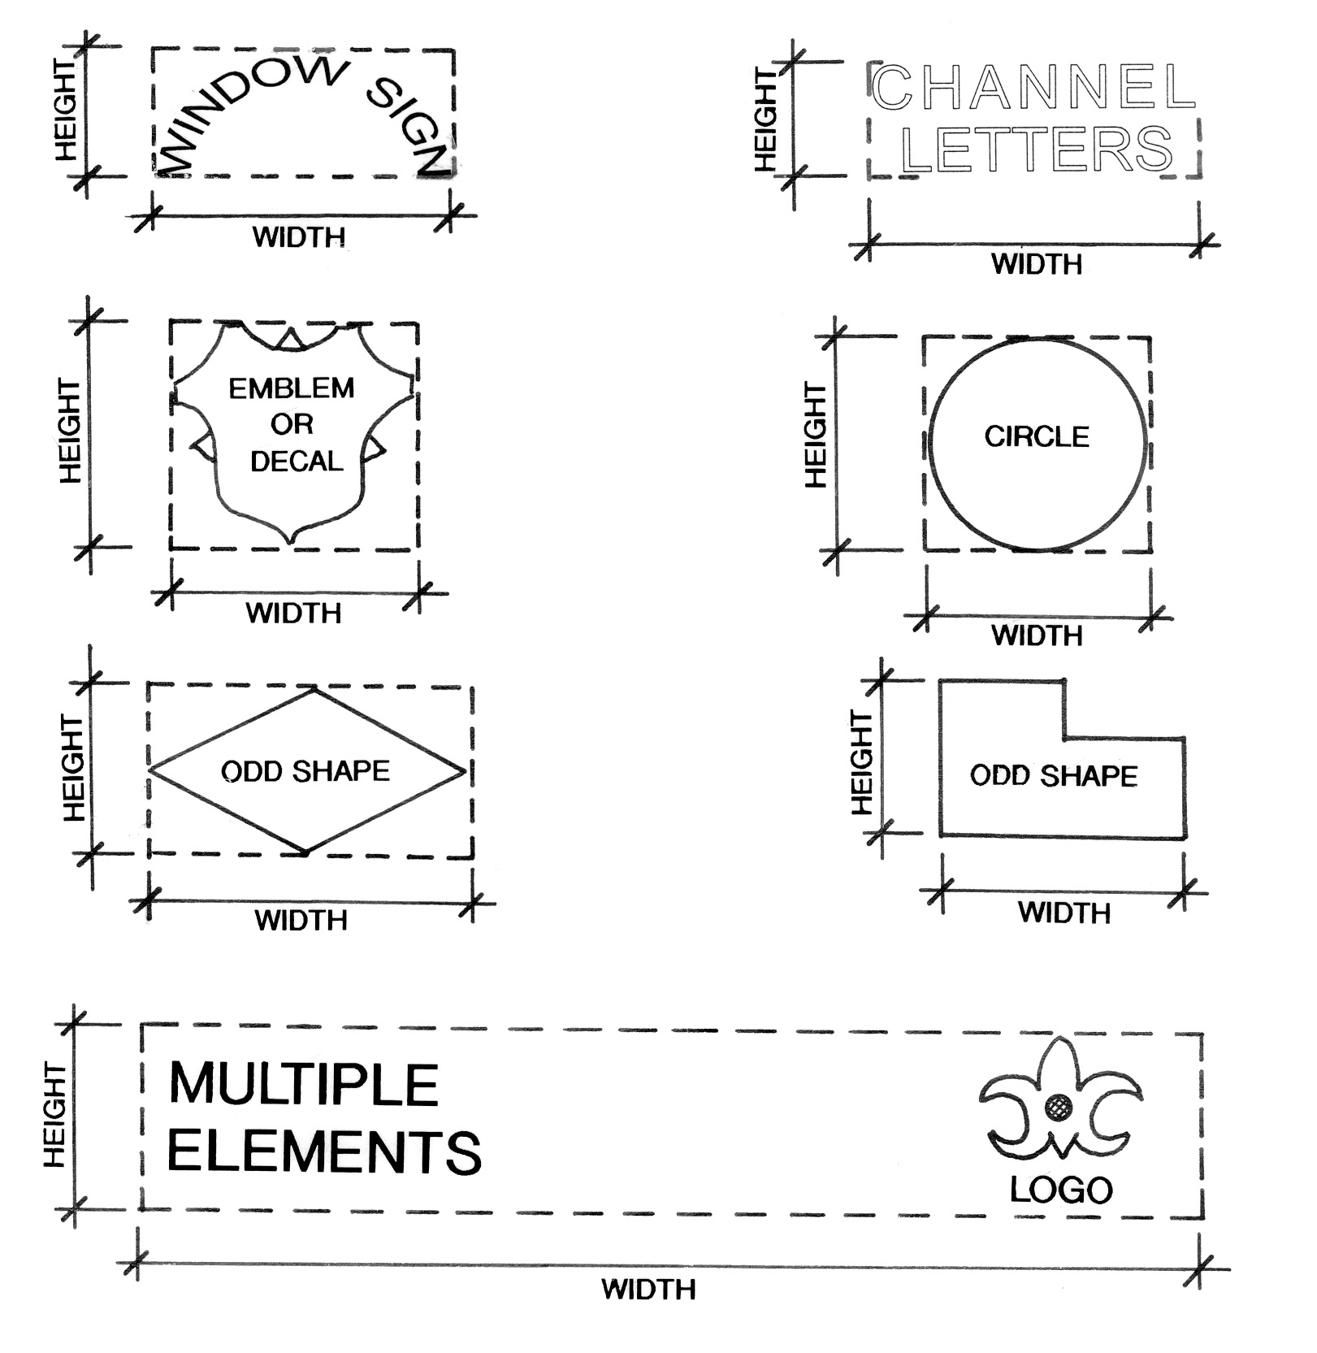

Submittal Requirement
All landscape and streetscape submittals shall provide a legend including information such as species, size, quantity, point value of plantings, and overall point totals.
Landscape & Streetscape Standards

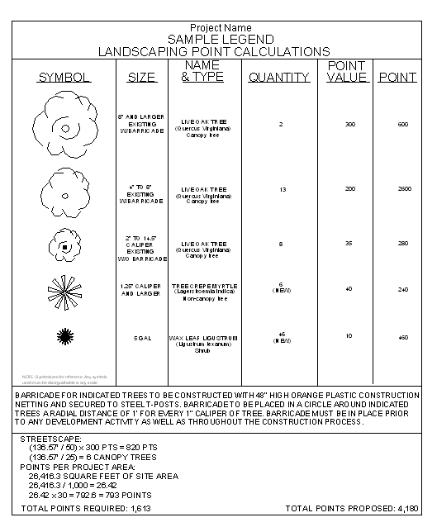

Tree Preservation
To receive barricaded points for existing trees, they must be barricaded one foot per caliper inch. A barricade detail must be provided on the landscape plan. Barricades must be in place prior to any activity on the property including, but not limited to, grading. If in any event the required barricades are not in place prior to any activity and maintained during construction, barricaded points will be forfeited.

Barricade Detail shown below:
Landscape & Streetscape Standards

Planting List
Landscape & Streetscape Standards
This list recommends several species that do well in the College Station/Bryan area. Not every species will perform well in all locations, and some species have detriments that need to be considered. Careful evaluation of the site, soils, available growing area, and climate needs to be exercised when selecting species. The legend below indicates how certain plantings may be utilized within a landscape plan. In addition, this legend also shares information regarding other specific attributes.
Qualifications Legend
*Recommended by Texas Forest Service for Brazos County
1=streetscape planting
2=screening
3=salt tolerant
4=evergreen
5=low water usage/drought tolerant
6=high water usage
7=native to Texas

Canopy Trees (40’+ canopy)
Common Name Scientific Name Qualifications
*American Elm (Ulmus Americana) 1, 3, 5, 7
*Bald Cypress (Taxodium distichum) 1, 3, 5, 7
*Bur Oak (Quercus macrocarpa) 1, 3, 5, 7
*Cedar Elm (Ulmus crassifolia) 1, 3, 5, 7
*Live Oak (Quercus virginia) 1, 3, 4, 5, 7
*Pecan (Carya illinoinensis) 1, 3, 5, 7
*River Birch (Betula Niagra) 1, 3, 7
*Shumard Red Oak (Quercus shumardii) or (Q. texana) 1, 3, 5, 7
*Water Oak (Quercus nigra) 1, 3, 7
*Western Soapberry (Sapindus drummondi) 1, 5, 7
*Willow Oak (Quercus phellow) 1, 3, 5, 7
American Sycamore (Platanus occidentalis) 3, 5, 7
Chinese Pistache (Pistacia chinensis) 1, 5
Chinkapin Oak 7 (Quercus muehlenbergii) 1, 5, 7
Drake Elm (Ulmus parvifolia 'Drake') 1, 4
Lacey Oak 7 (Quercus glaucoides) 5, 7
Leyland Cypress (Cupressocyparis leylandii) 3, 4(semi)
Post Oak- existing only (Quercus stellata) 7, 8
Canopy Trees continued…
Landscape & Streetscape Standards
Texas Ash (Frazinus texensis) 1, 3, 5, 7
Texas Pistache 8 (Pistachia texana) 1, 4, 5, 7
Winged Elm 6 (Ulmus alata) 1

Non-Canopy Trees
Common Name Scientific Name Qualifications
*American Holly (Ilex opaca) partial to shade 1, 3, 4, 5, 7
*Carolina Cherry Laurel (Prunus caroliniana) 1, 3, 4, 5, 7
*Chaste Tree (Vitex Negundo) 1, 3, 5
*Crepe Myrtle (Lagerstroemia indica) 1, 3, 5
*Eastern Red Cedar (Juniperus virginiana) 1, 3, 4, 5, 7
*Eve’s Necklace tree (Sophora affinis) 1, 5, 7
*Goldenrain Tree (Koelreuteria paniculata) 1, 3, 5
*Japenese Black Pine (Pinus thunbergiana) 1, 3, 4, 5
*Lacebark Elm (Ulmus parvifolia) similar to Siberian Elm 1, 3, 5
*Mexican White Oak (Quercus polymorpha) 1, 4(semi), 5, 7
*Mexican Plum (Prunus mexicana) 1, 4(semi), 5, 7
*Possumhaw Holly (Ilex decidua) 1, 5, 7
*Prairie Flameleaf Sumac (Rhus lanceolata) 1, 5, 7
*Texas Red Bud (Cercis canadensis) 1, 5, 7
*Tree Yaupon (Ilex vomitoria) 1, 3, 4, 5, 7
Bradford Pear (Pyrus species) 1, 5
Chinese Fringe tree (Chionanthus retusus) 5
Coppertone Loquat (Eriobotrya japonica)* 4
Italian Cypress (Cupressus sempervirens) * 3, 5
Rusty Blackhaw Viburnum (Viburnum rufidulum) 1
Shining Sumac (Rhus copalina) 1, 5, 7
Texas Kidneywood (Eysenhardtia texana) 5, 7
Texas Mountain Laurel (Sophora secundiflora) 1, 3, 4, 5
Texas Persimmon (Diospyros texana) 1, 5, 7
Wax Myrtle Tree (Myrica cerifera) 1, 4, 5, 7

Shrubs (Please be aware that dwarf species are not permitted in required screening areas or in required buffer areas.) (grasses must be a perennial)
Landscape & Streetscape Standards
Common Name Scientific Name Qualifications
Adam’s Needle Yucca (Yucca filamentosa) 3, 4, 5
Abelia (Abelia grandiflora) 2, 5
Althea (Hibiscus syriacus) 2,3, 5
Agrito (Berberis trifoliolata) 2, 4
American Beautyberry (Callicarpa amercicana) 3, 5
Aromatic Sumac (Rhus aromatic) 3, 5
Belinda’s Dream Rose (Rose ‘Belinda’s Dream’) 2, 5, 7
Boxwood (buxus) multiple varieties 2, 4, 5
Carolina Buckthorn (Rhamnus caroliniana) 5
Carolina Laurel Cherry (Prunus caroliniana 'Bright 'n Tight’) 2, 3, 4, 5, 7
Pruned properly for screening, not height
Cast Iron plant (Aspidistra elatior) – needs shade 5
Clyera (Ternstromia gymnanthera) 2, 4, 5
Elaeagnus (Elaeagnus macrophylla) 2, 3, 5
Acanthus (Anisacanthus quadrifidus var 'wrightii') 5
Fountain grass (Pennisetum setaceum) 5
Gold Dust Aucuba (Aucuba japonica)* 2, 4, 6
Golden Euonymus (Euonymus japonica 'Aureo-marginata') 2, 3, 4, 5
Gold Star Esperanza (Tecoma stans ‘Gold Star’) 3, 5, 7
Grandma’s Yellow Rose (Rose ‘Nacogdoches’) 5, 7
Gulf Muhly grass (Muhlenbergia capillaries) 5
Hicks Yew (Taxus x medua ‘Hicksii’) 2, 4, 5(semi)
Holly, upright (zone appropriate species) 2, 3, 4, 5
Indian Hawthorn (Rhaphiolepis indica) 2, 3, 4, 5
Juniper species, upright (Juniperus species) 2, 3, 4, 5
There are many varieties of Junipers but be careful to avoid the ones with bagworm susceptibility
Knock-Out Rose (Rose ‘Radrazz’)* 5
Maiden grass (Miscanthus sinensis) 2, 3, 5
Mexican Bush Sage (Salvia leucantha) 2, 5
Nandina (Nandina domestica 'compacta') 2, 3, 4, 5
or others if zone appropriate

Shrubs continued…
Landscape & Streetscape Standards
Oleander (Nerium oleander sp.) 2, 3, 4, 5
red or white are the hardiest
Pampas Grass (Cortaderia selloana sp.) 3, 4(semi)
Photinia Species (Photinia x fraseri) 2, 4
Pineapple Guava (Feijoa sellowiana) 2, 3, 4, 6
Pittosporum Species (Pittosporum tovira) 2, 3
Primrose Jasmine (Jasminum mesnyi) (J. primulinum) 2, 4, 6
Pyracantha (Pyracantha species) 2, 4
Rosemary, upright (Rosmarinus officinalis) 2, 4, 5
Russian Sage (Peroxskia longifolia) 3, 5
Sago Palm (Cycas revolute) 3, 4
Soft Leaf Yucca (Yucca recurvifolia)* 3, 5
Spirea (Spirea species) 2, 5
Texas Firecracker Bush (Hamelia patens) 3, 5
Texas sage (Leucophyllum frutescens) 2, 3, 4, 7
('Greencloud' or sp.)
Viburnum species (Leatherleaf, Walter’s(3) 2, 3, 4
Viburnum macrophyllum or sp.)
Waxleaf Ligustrum (ligustrum japonicum) 2, 3, 5
Wax Myrtle (Myrica pusilla) 2, 3, 4, 5
Whitebrush (Aloysia gratissima) 2, 5, 7
Yaupon (Ilex vomitoria 'nana') 2, 3, 5

Groundcovers and Vines (grasses must be a perennial)
Common Name Scientific Name Qualifications
Asparagus Fern (Asparagus densiflorus) 3
Algerian Ivy (Hedera canariensis) 4, 6
Asian Jasmine (Trachelospermum asiaticum) 4(semi),5(semi)
Baby Sun Coreopsis (Coreopsis g. 'baby sun') 5
Big Blue Lily Turf (Liriope Muscari) 4, 5
Carolina Jessamine (Gelsemium sempervirens) 4, 6
Creeping Juniper (Juniperus horizontalis) 4, 5
Daylilly (Hemerocallis) 3
Landscape & Streetscape Standards
Dwarf Pampas Grass (Cortaderia selloana 'Pumila') 3, 4(semi)
English Ivy (Hedera helix) 3

Groundcover and Vines continued…
Landscape & Streetscape Standards
Star Jasmine (Trachelospermum jasminoides) 4
Gregg Salvia (Salvia Greggii) 4, 5
Henry Duelberg Salvia (Salvia farinácea ‘Henry Duelberg’) 5, 7
Monkey Grass (Ophiopogon japonicum) 4, 6

Mexican Feather Grass (Nassella tenuissima) 5
Ribbon Grass (Phalaris arundinacea) 5
Sage (Salvia Farinacea) 2, 3, 4
Small-leaf Spiderwort Tradescantia fluminensis) 4, 5
Texas Lantana (Lantana horrida) 3, 7
Turk’s Cap (Malvaviscus arboreus 'drummondii') 4(semi), 7
Vinca (Vinca major and V. minor) 4, 6

Turfgrasses
Common Name Scientific Name Qualifications
Buffalo grass (Anthoxanthum odoratum) 5, 7
Common Bermuda (Cynodon dactylon) 3, 5 (semi)
Tifway 419 Bermuda (Cynodon 'TIFF 419') 5 (semi)
St.Augustine (Stenotaphrum secondatum) 3, 6
Zoysia (Zoysia species) 3, 5

Gated Entry Standards

Gated Entry Geometric Standards

The gate(s) may not be placed on a public right-of-way or easement.

All gate mechanical or manual operating functions shall meet the City’s Fire Department requirements and provide passage with unobstructed vertical clearance.

The throat depth for a gated entry way shall be a minimum of one-hundred feet (100’) (Ref. Figure 1).

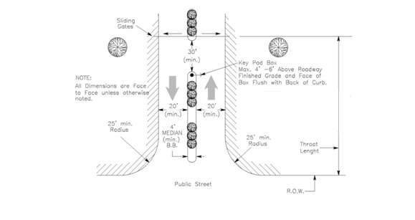

Gated entry ways shall provide adequate access for pedestrians and bicycles.

Gated entry ways shall provide adequate turnaround areas for vehicles that are denied access in order to prevent backing into a public street. (Ref. Figure 1 above)

The gated entry way driveway pavement widths, for both egress and ingress, shall be a minimum of twenty feet (20’) per driveway and are required to provide a minimum four feet (4’) center median. (Ref. Figure 1 above)

The gated area shall provide a minimum unobstructed vertical clearance of fourteen feet and six inches (14’-6”) from finished roadway surface over the entire width of the entry roadway.

Public safety elements and signing shall be included in the gated entry way design.

The following General Notes should be included on the Site Plan:
General Site Plan Notes

- "All roof and ground-mounted mechanical equipment shall be screened from view or isolated so as not to be visible from any public right-of-way, measured from a point five feet above grade. Such screening shall be coordinated with the building architecture and scale to maintain a unified appearance."

- "100% coverage of groundcover, decorative paving, decorative rock, or a perennial grass is required in parking lot islands, swales and drainage areas, the parking lot setback, rights-of-way, and adjacent property disturbed during construction."

- "Irrigation system will be protected by either a Pressure Vacuum Breaker, a Reduced Pressure Principle Back Flow Device, or a Double-Check Back Flow Device, and installed as per adopted City building code."

- "All back flow devices will be installed and tested upon installation as per adopted City Building Code.

