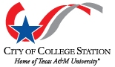

Program Visibility

The City of College Station will inform the public of the nondiscrimination policies, procedures and other related information. All of the city’s external and internal communications methods will be utilized to share information about the Title VI Nondiscrimination policies and plans. They can be made available on: the city’s websites, social media pages, government access channel, other publications displayed in city buildings, at public meetings and other forms of outreach. We will display Title VI related posters in prominent locations in city buildings and when needed and appropriate, they will be in languages other than English.

